DevOps

DevOps-It is a methodology in software development cycle like continuous integration and continuous deployment(CI/CD).

In CI/CD we are going to use different kinds of tools which are available in the market.

Tools used to setup CI/CD:

* Git- SCM or Repository used to store developers code.
* Jenkins- Continuous Integration tool which helps to integrate Development and Operation.
* Maven- Project management tool.
* Ansible- Tool which is used to automate IT Infrastructure.
* Docker- Container platform used to deliver software in a packages.
* Kubernetes- Container orchestration system which is used to automate application deployment and management of containerized applications.
* MS Azure- Public cloud used to deploy our cloud services.
* Nagios- Monitoring Tool used monitor infrastructure.

Pre-requisites:

* GitHub Account
* Simple Java Project
* Azure Account
* Jenkins Server(Linux)
* Git Installation and Configuration
* Tomcat Server(Linux)

Create GitHub account:

Here I created a GitHub account and added two new repositories in public which is easy to access in public network. In case, if we need repositories to be more secure we can create a repository in private mode (need to provide credentials for private mode).

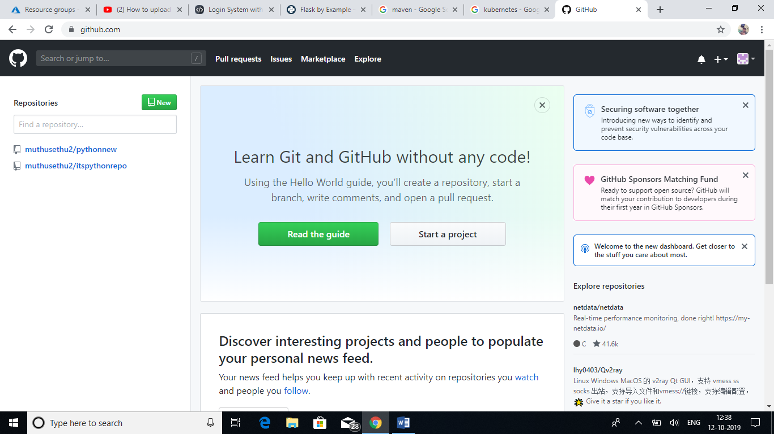

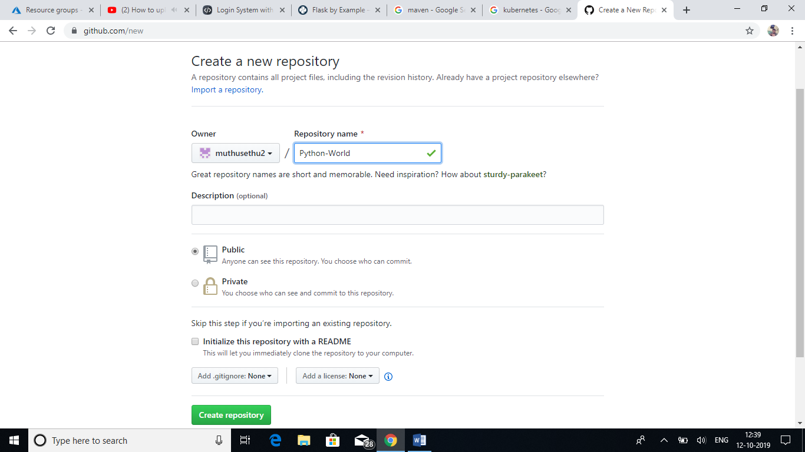

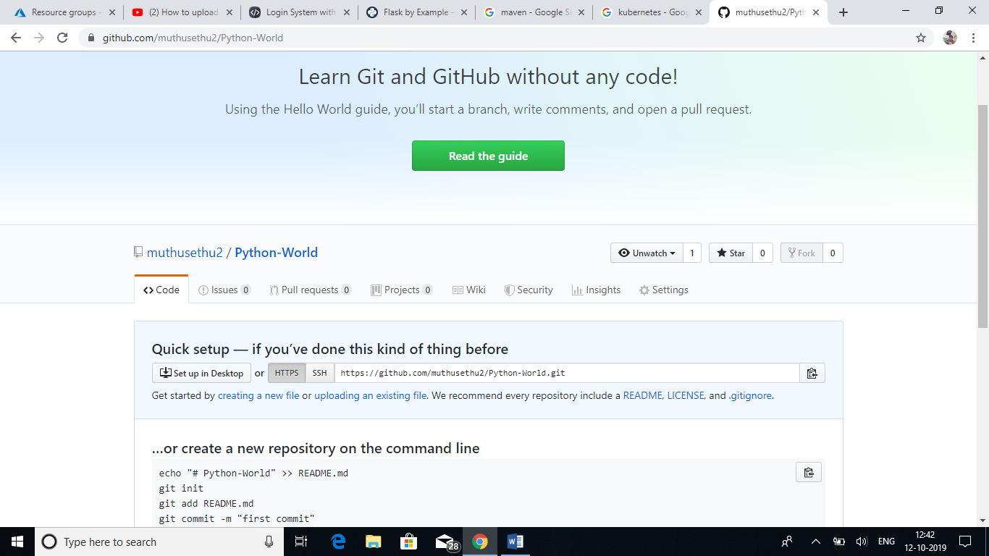

Once we created a repository, its generates a unique URL for the repository. We can use that URL to access the repository. I pushed some sample codes in the repository by using upload files option in GitHub.

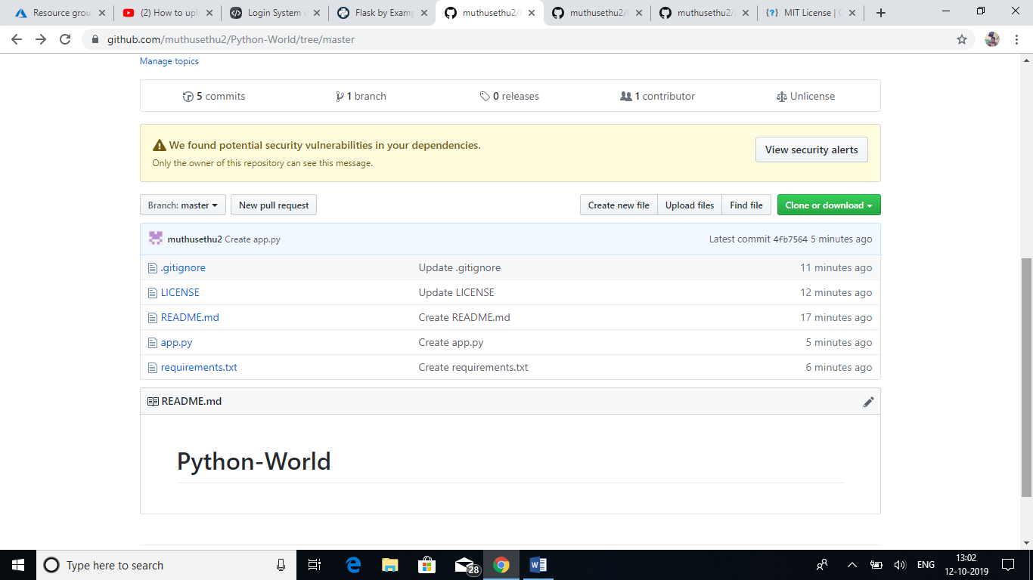

Create Azure VM:

We need a Servers for hosting Jenkins (Continuous Integration tool) and Tomcat (Web Server). Here I am using Linux (Red Hat 7) server for hosting Jenkins and Tomcat.

Deploy Red Hat server in Azure:

Before that we need to setup SSH key pair between Azure and the VM which is going to create. By using the below command to create a private and public key in Azure.

# ssh-keygen –t rsa –b 2048

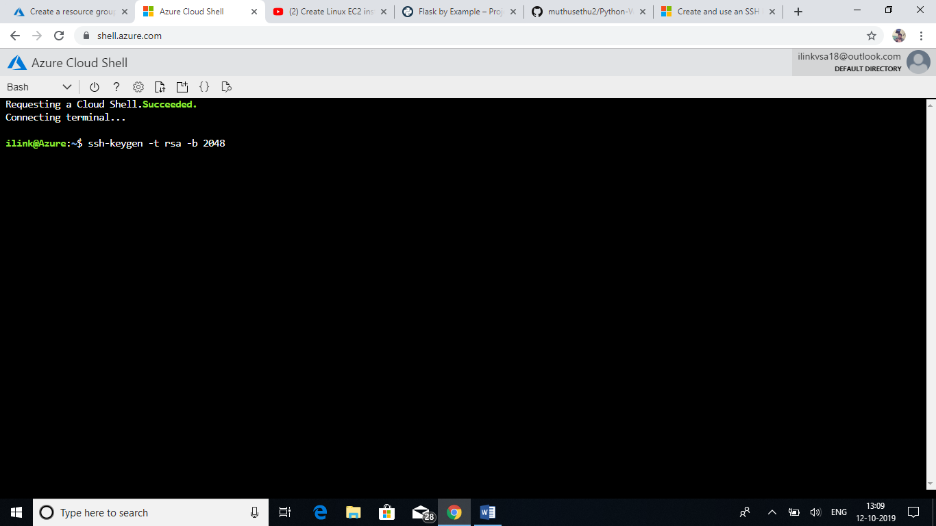

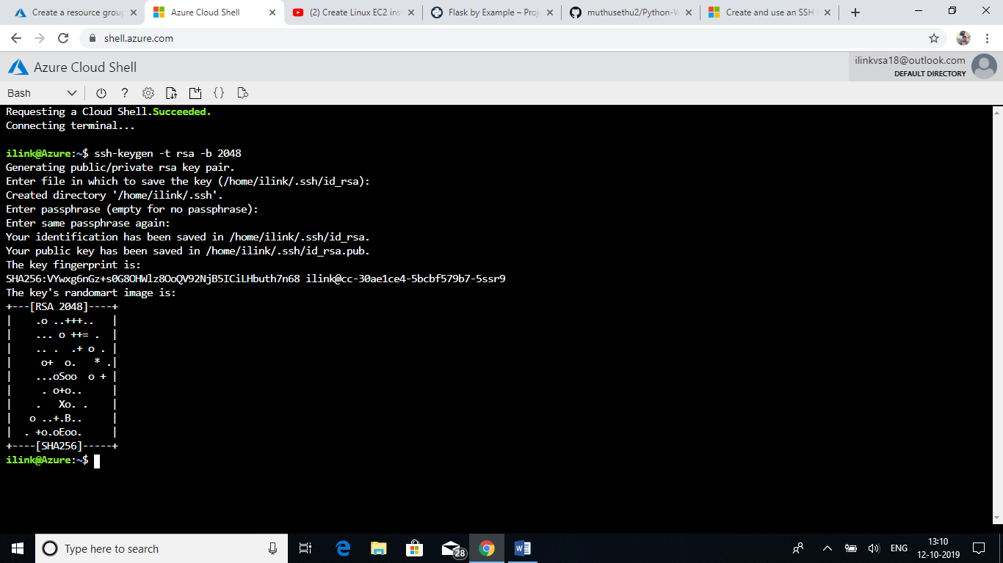

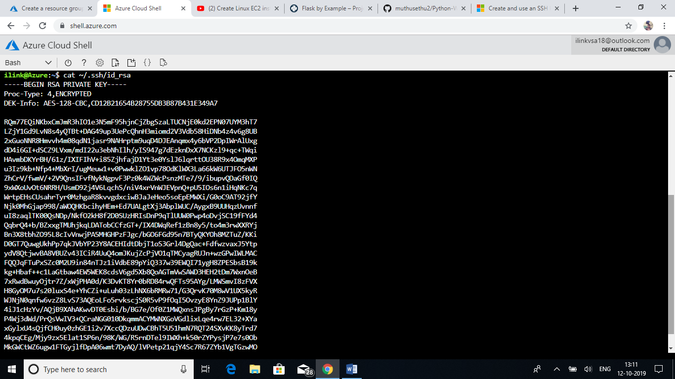

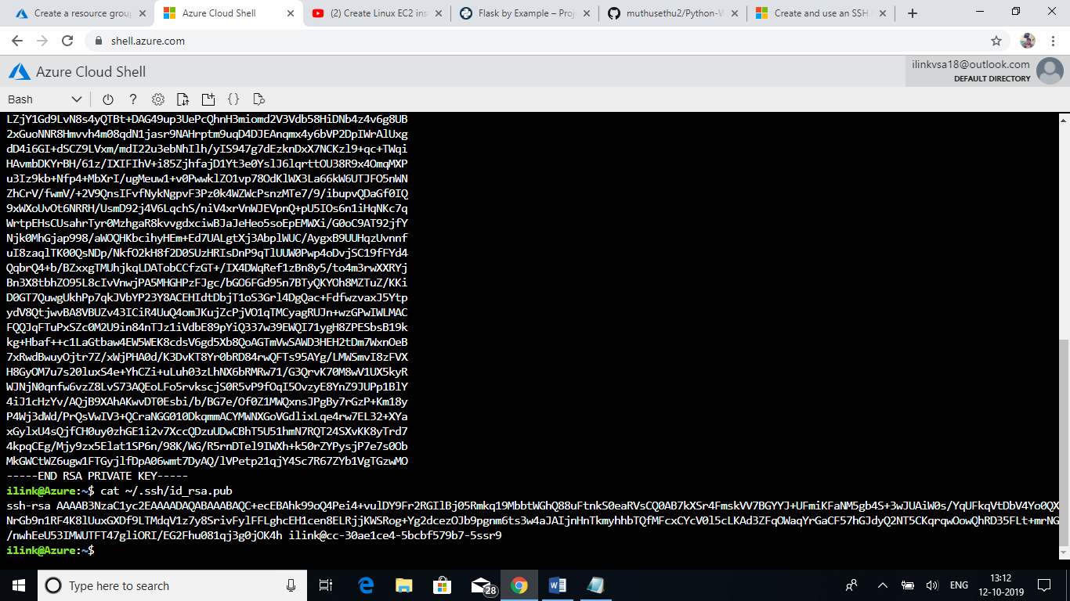

After that

Go to Virtual machines🡪Add

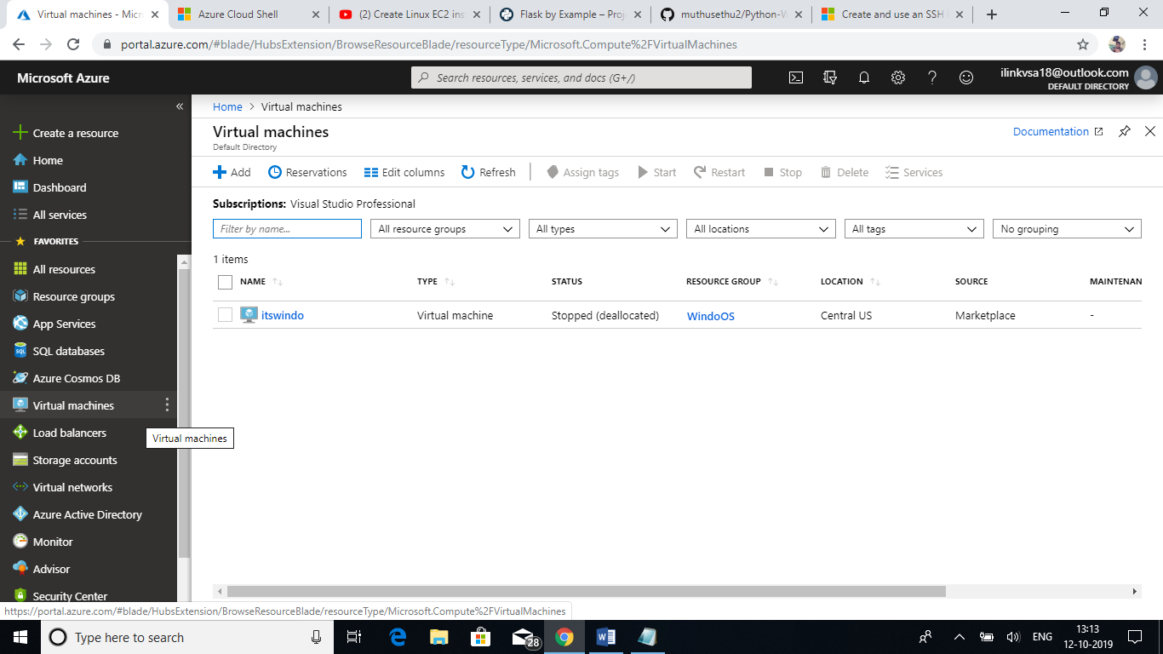

Provided the required project details in the needed fields.

* Selecting the image as Red Hat Enterprise Linux 7.4

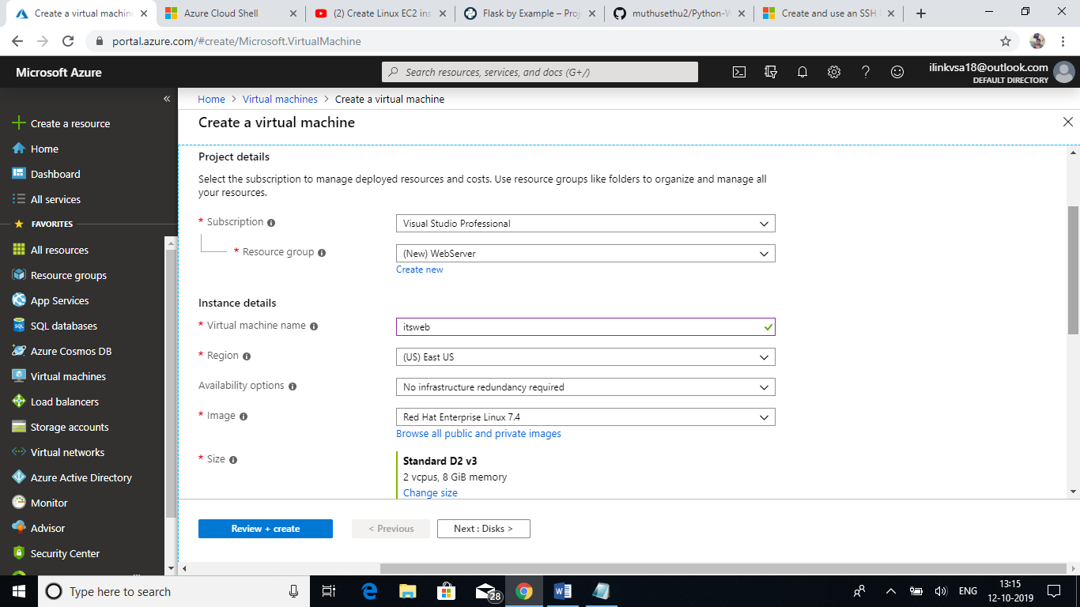

Provided the Username and SSH Public key which is generated in the previous step in the required field. Also selecting the inbound ports need to access in internet.

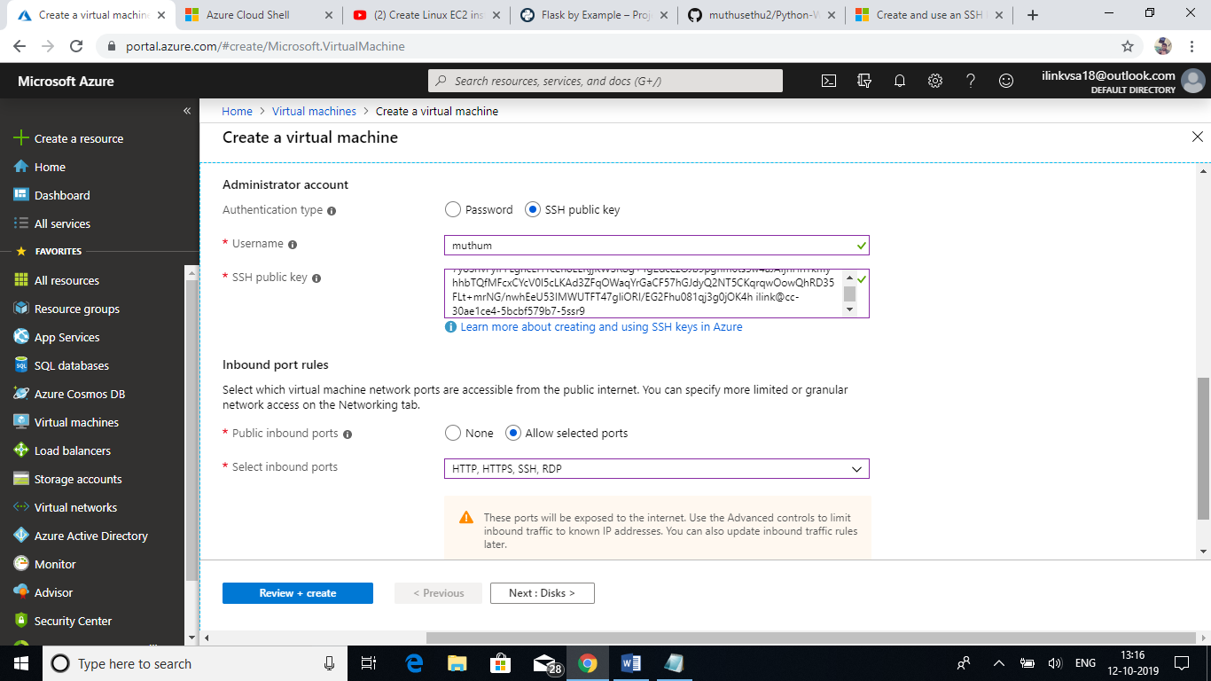

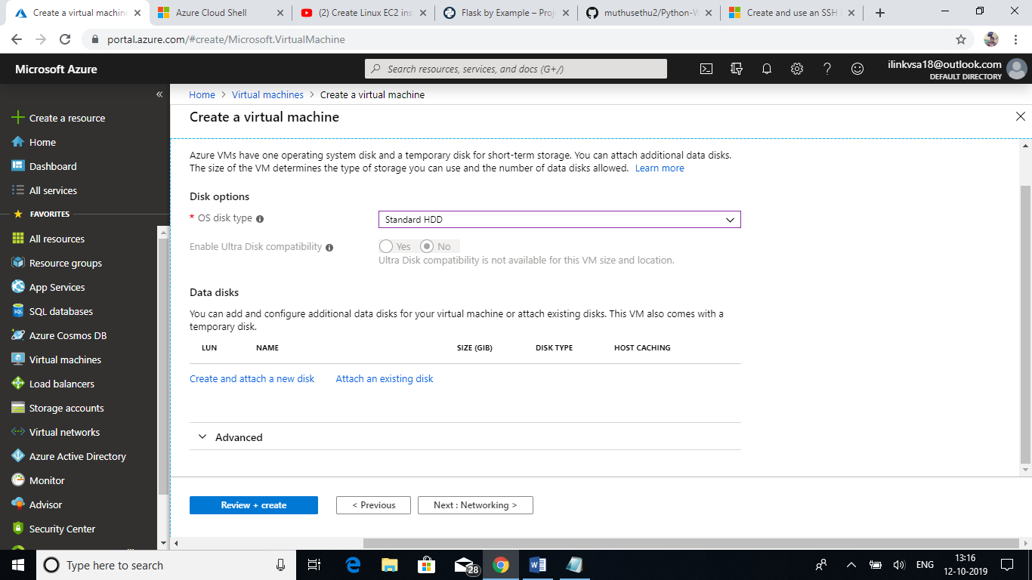

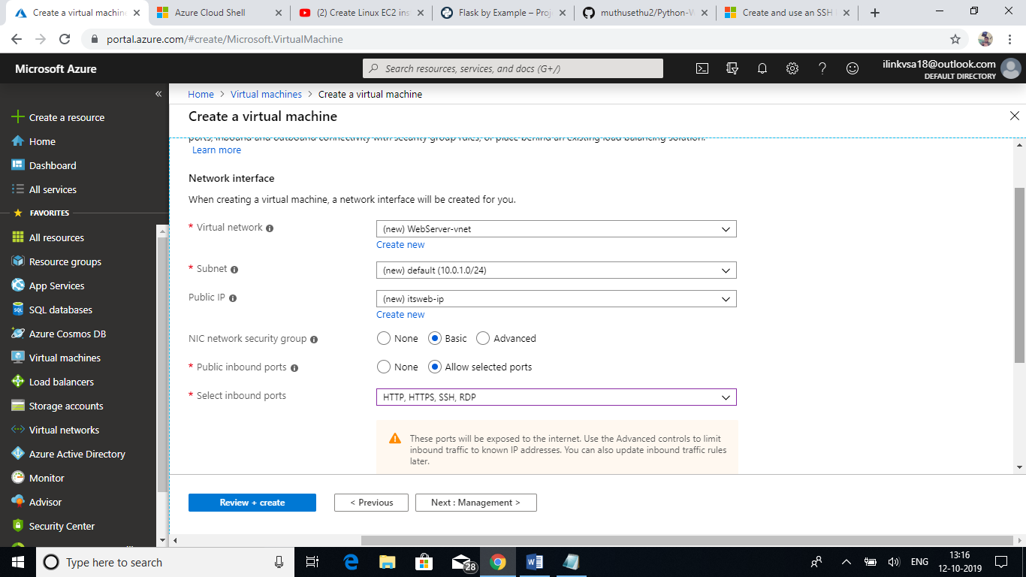

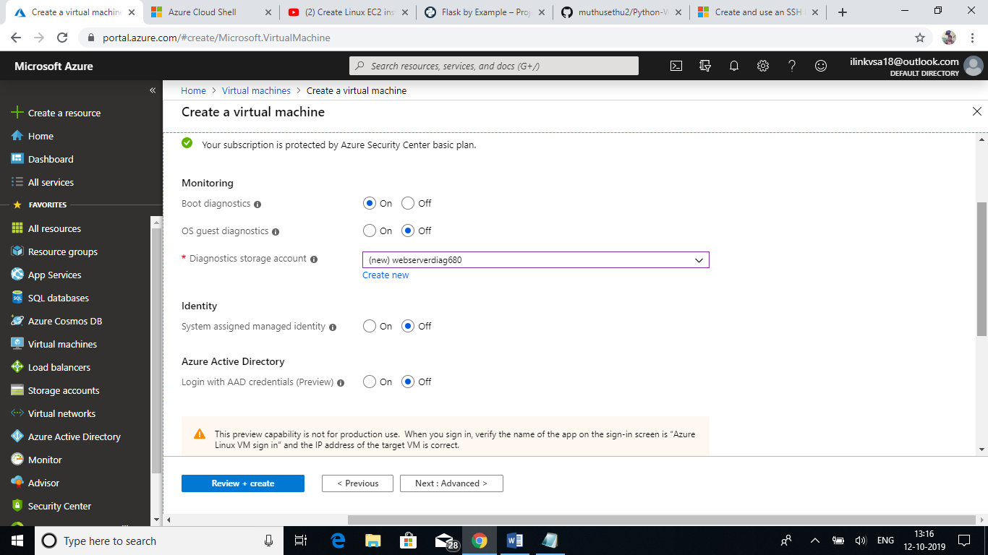

Click review and create option to create the Linux VM.

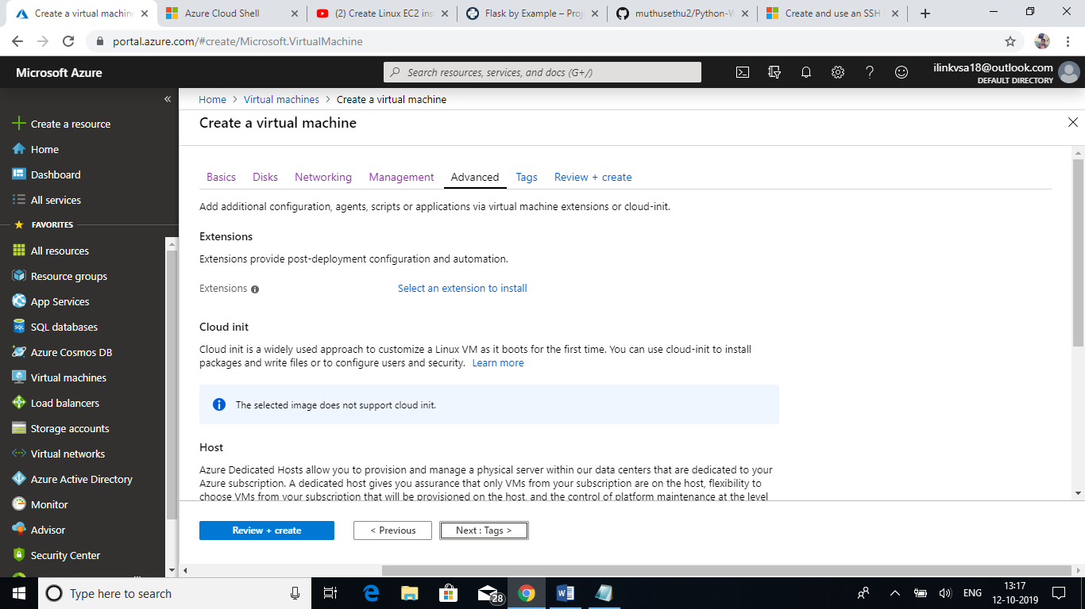

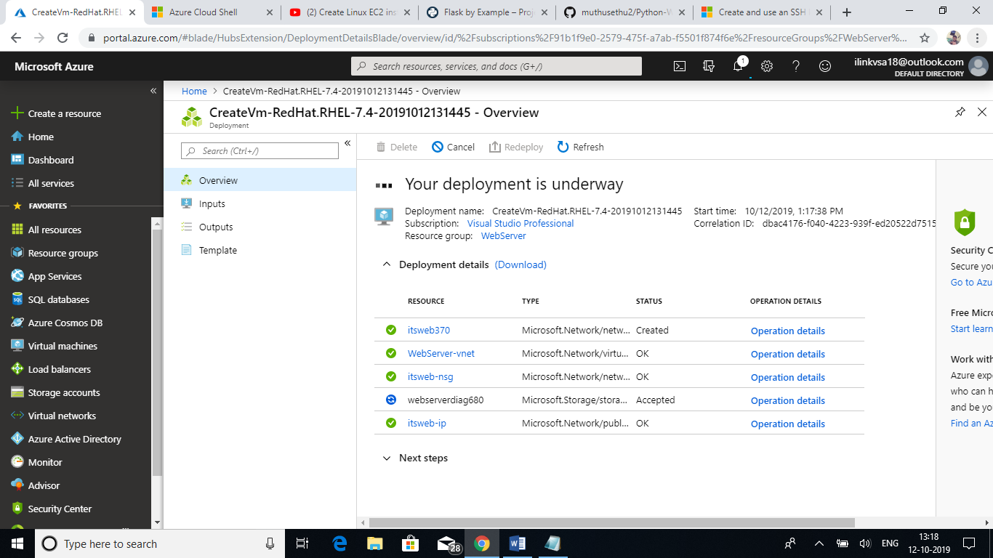

Finally, the deployment would be completed.

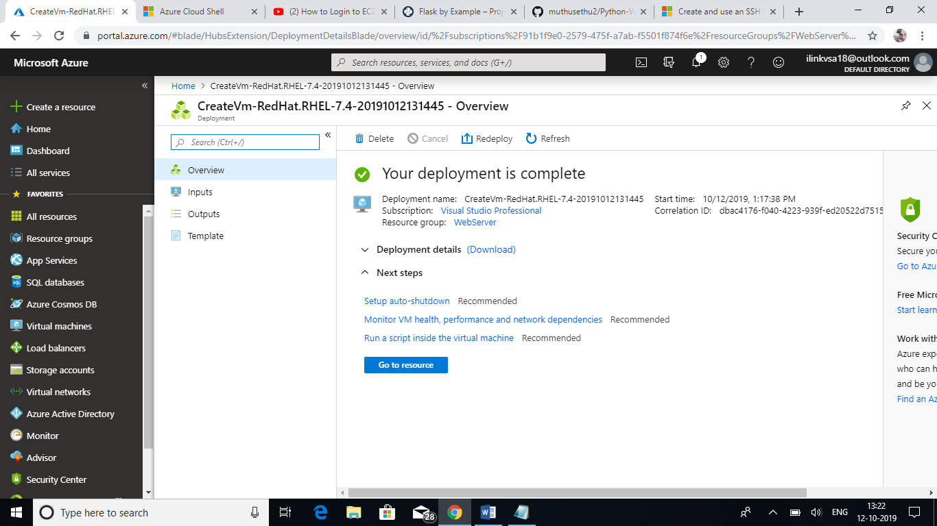

Go to Virtual machines🡪Select the VM🡪Click Overview

* It shows the complete details about our VM like OS, Storage, Private IP, Public IP etc.
* We can use the Public IP to connect the VM.

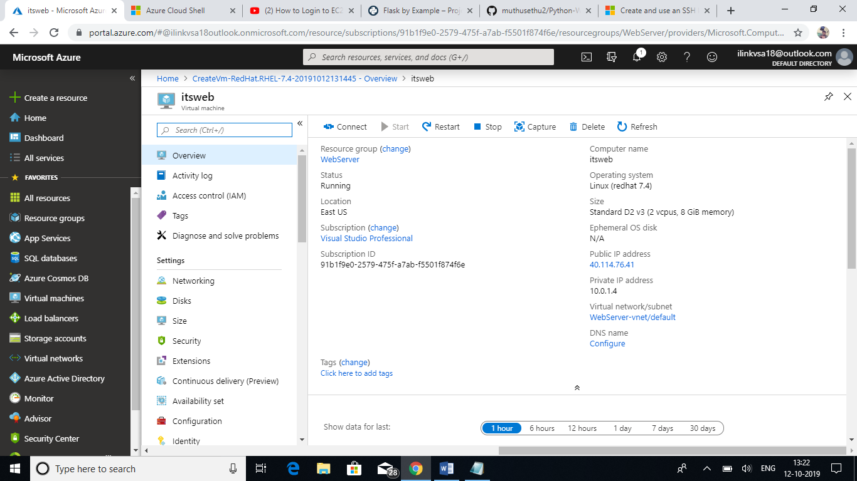

We can use a tool like Putty or <https://shell.azure.com/> to connect the VM. MobaXterm is also another third party tool which is used to connect the VM. I am using this here.

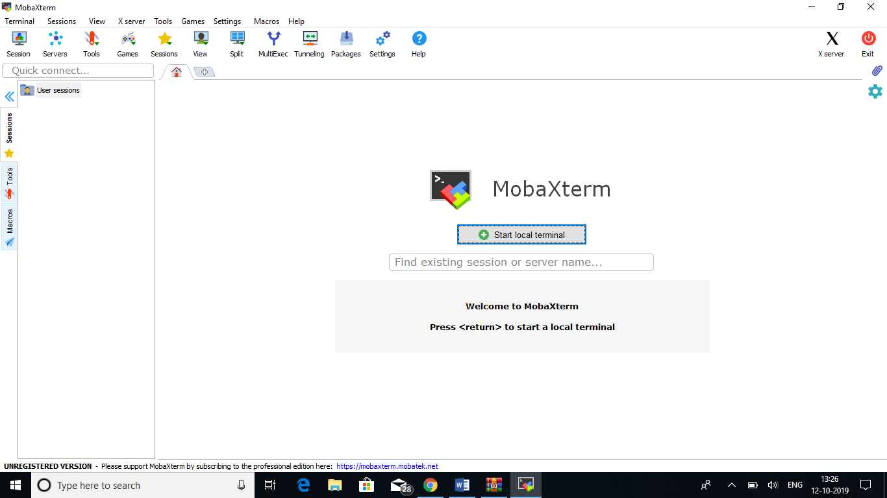

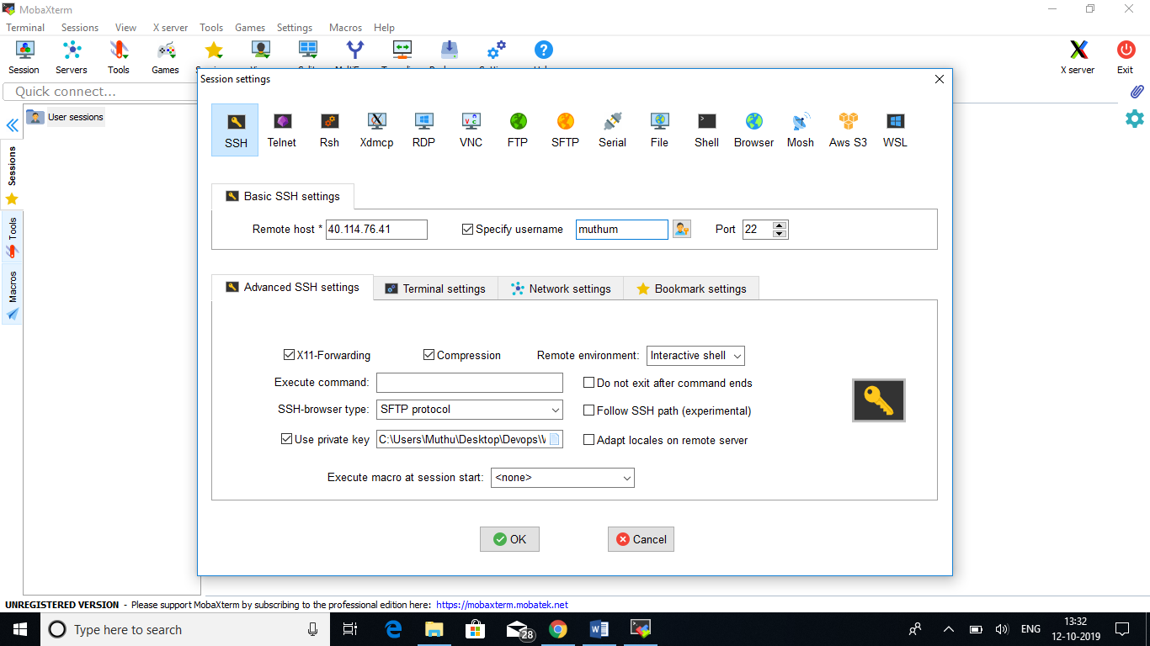

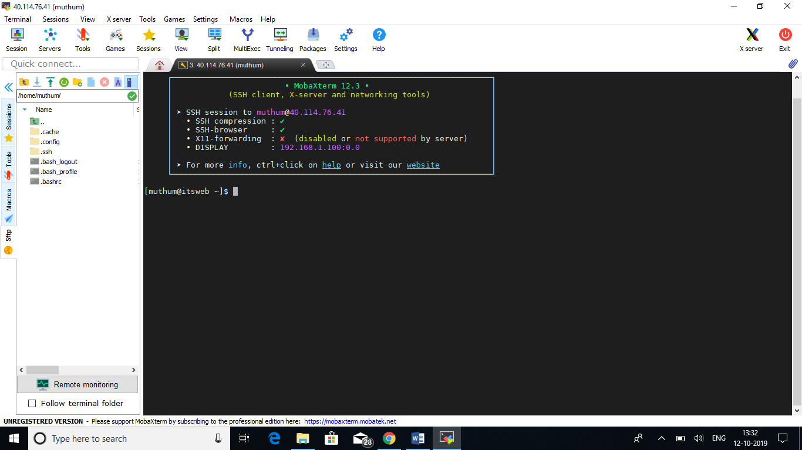

Jenkins needs a Port 8080 to be open. So that we can able to access Jenkins in Public. In Azure,

Go to the VM🡪Networking🡪Inbound port rules🡪Add Inbound port rule

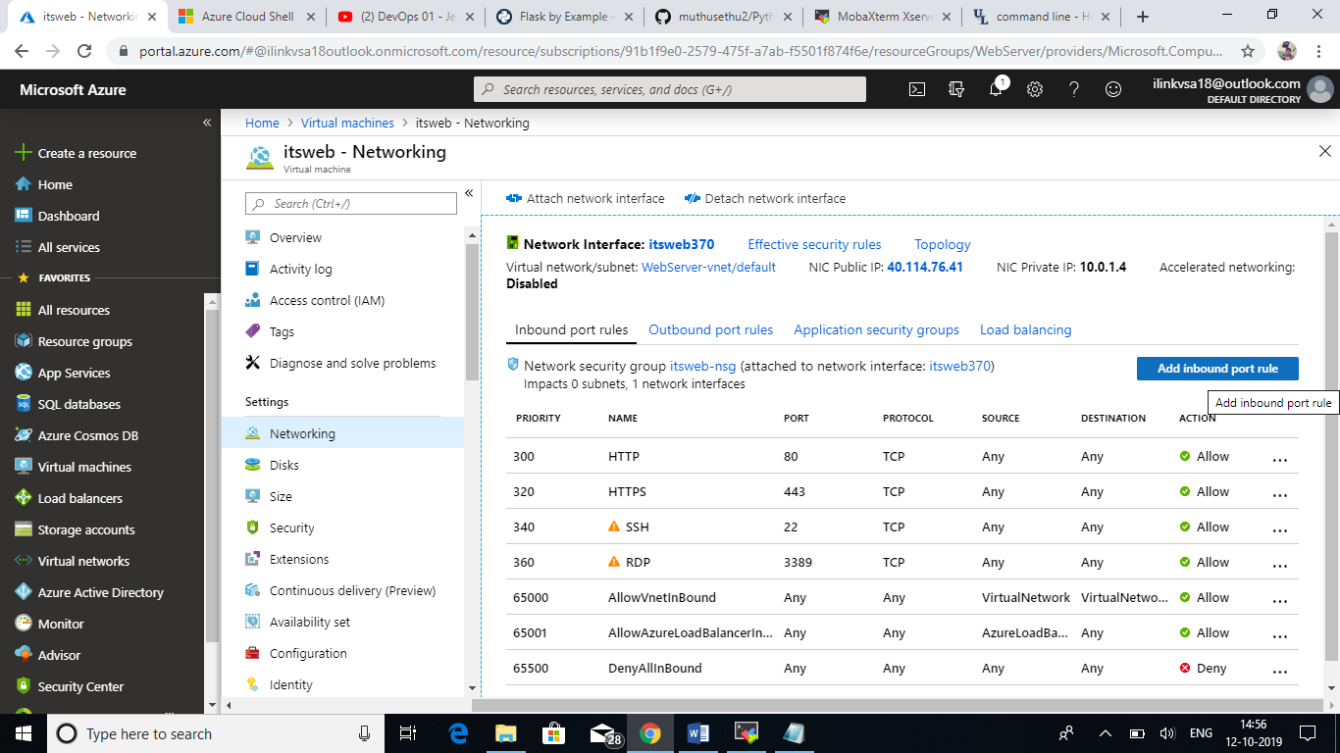

Set Destination Port range is 8080 and provide the desired name to the rule.

Click Add.

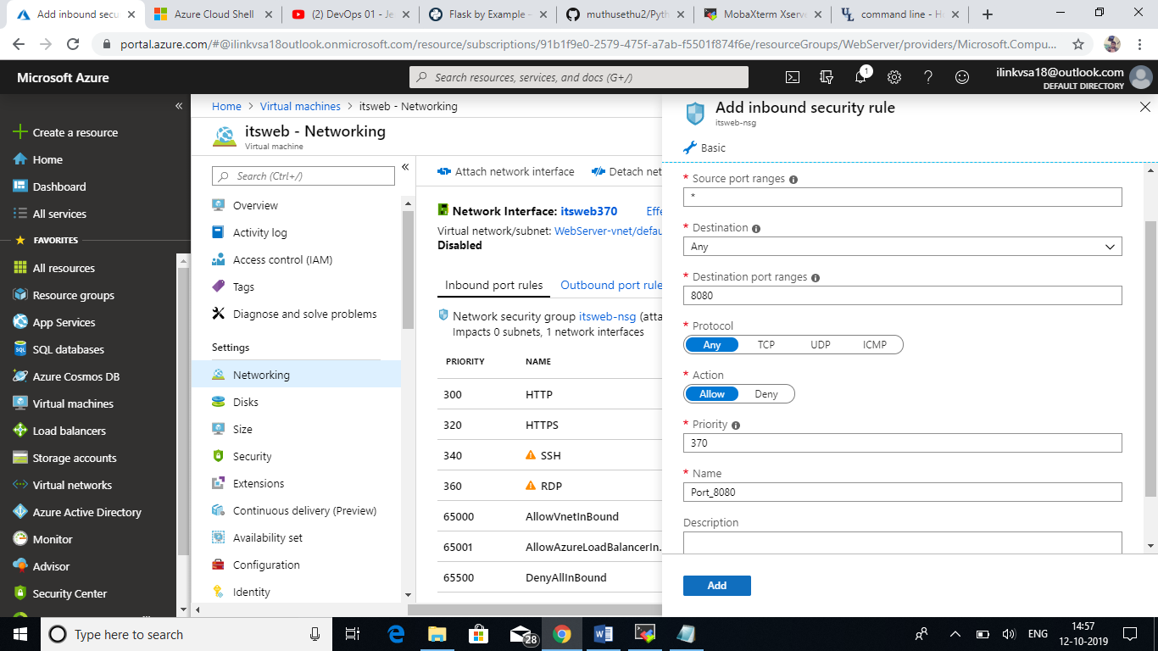

Install Java and Jenkins in Red Hat server:

Pre-requisites for Jenkins:

* Security group with Port 8080 open for internet.
* Java v1.8.x

Installing Java by using the below command

# yum –y install java-1.8*

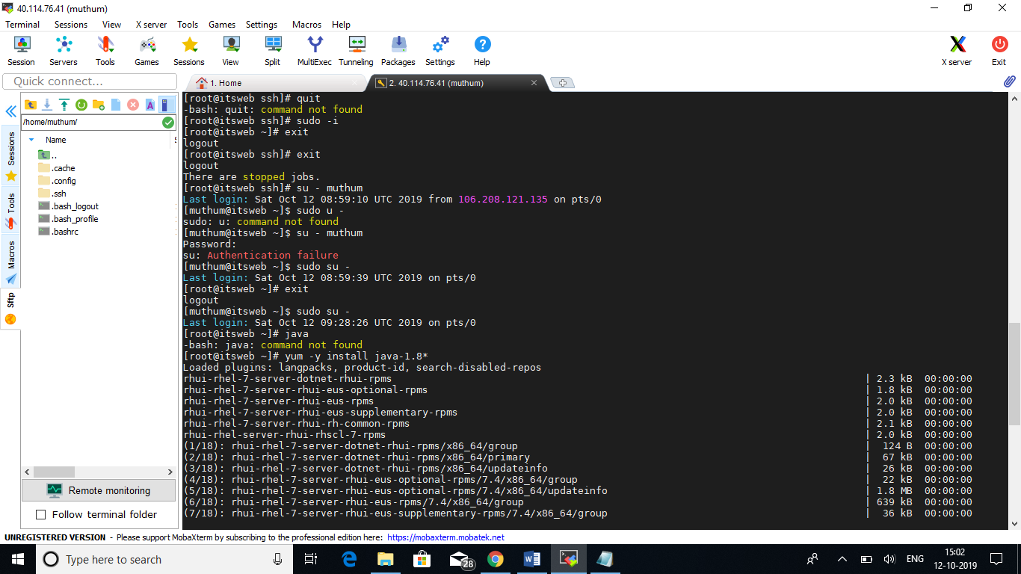

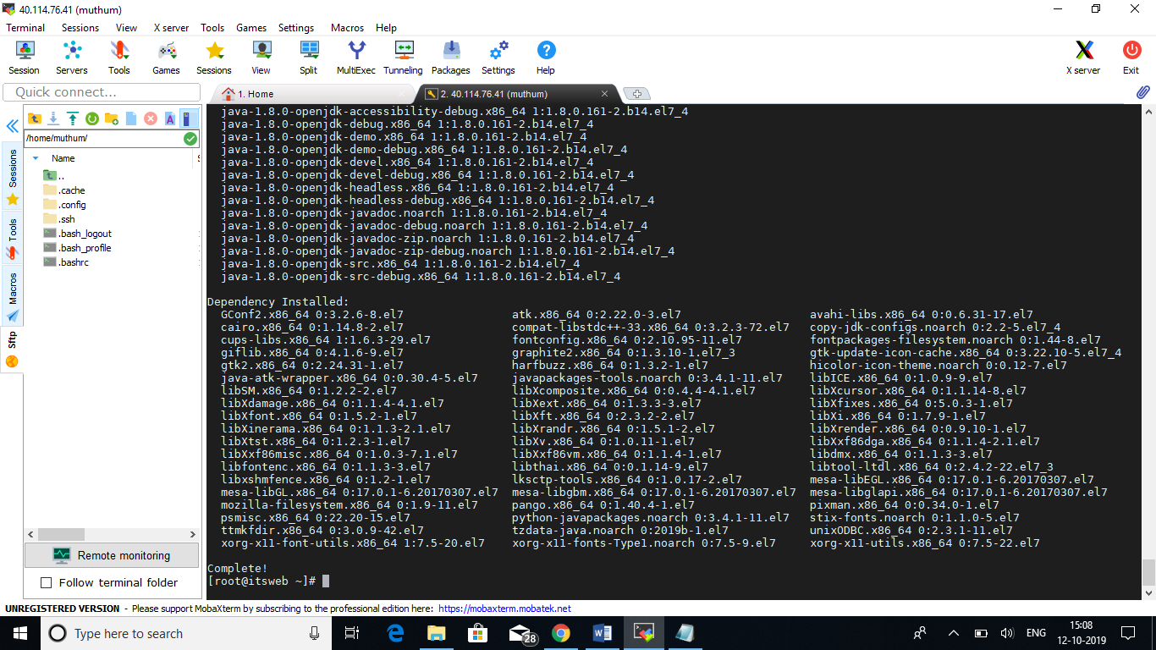

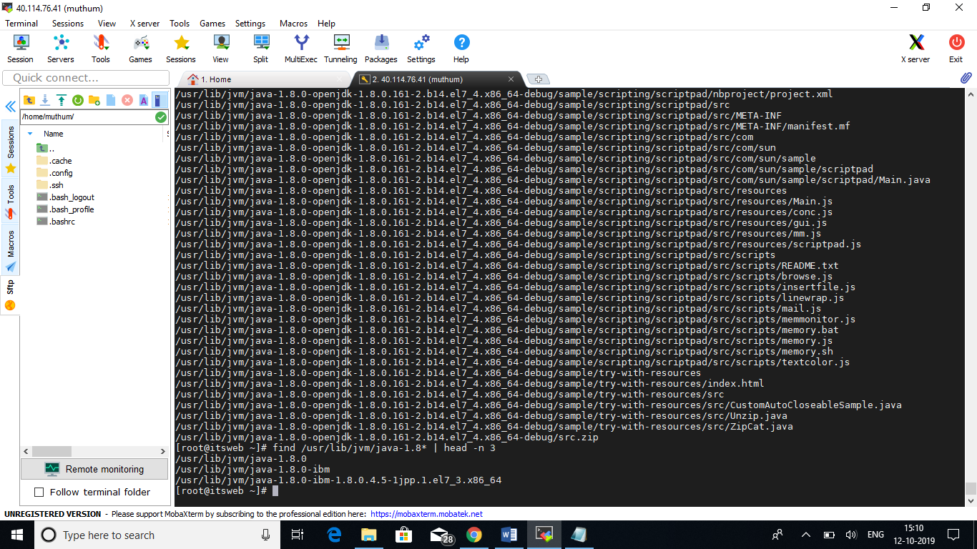

Once installed, we need to set a PATH for accessing Java.

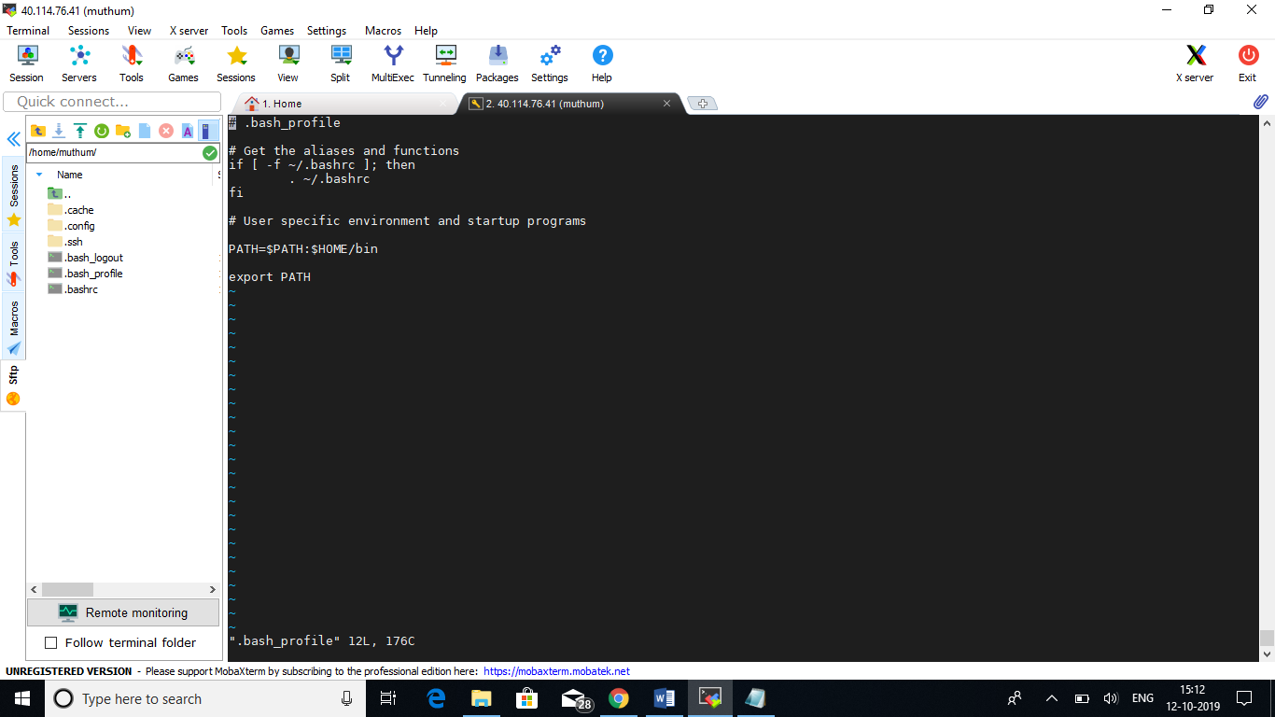

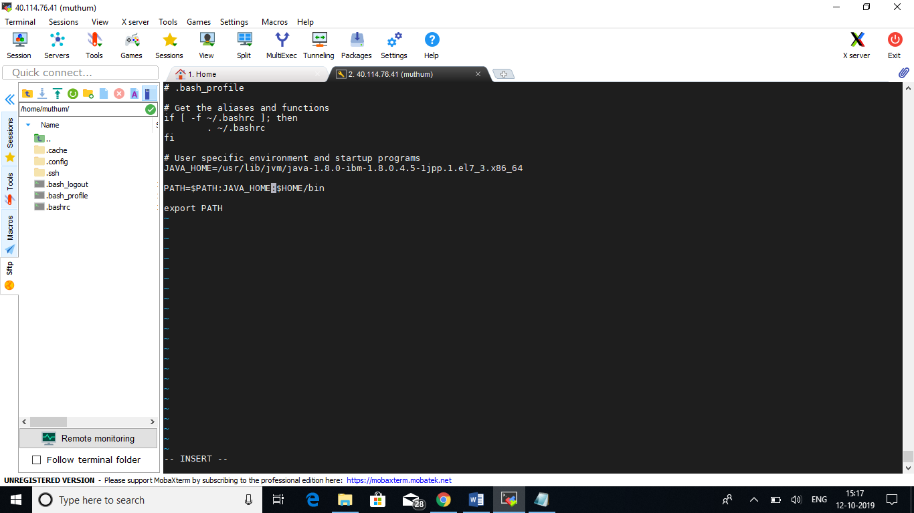

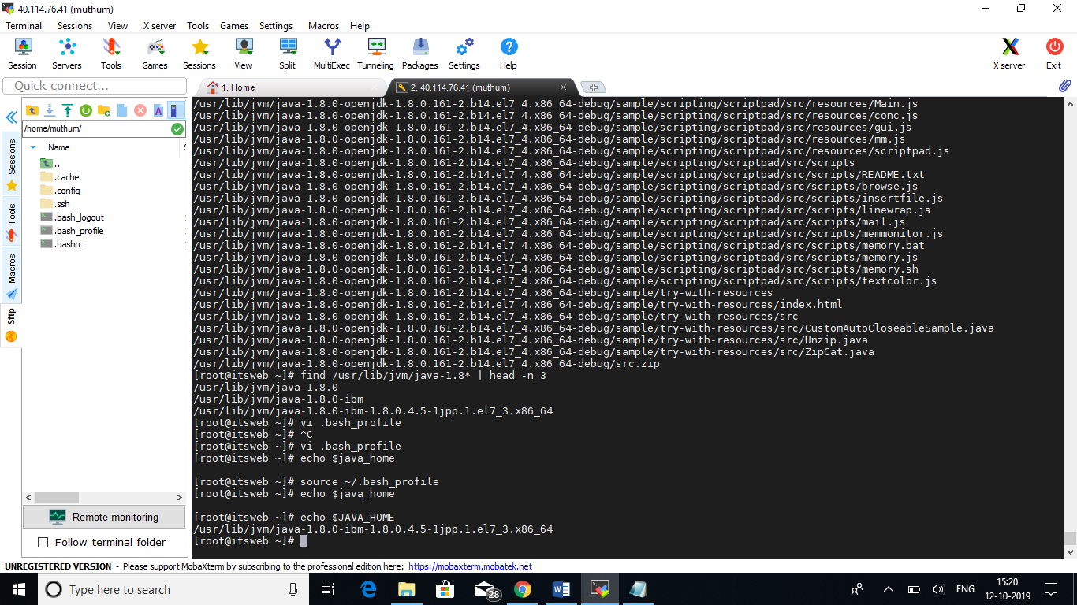

After setting up the path for Java we can move on to Jenkins installation. Below is the command used for Jenkins Installation.

# wget –O /etc/yum.repos.d/jenkins.repo <https://pkg.jenkins.io/redhat-stable/jenkins.repo>

This command will download the Jenkins package in the path which is provided above.

# rpm –import <https://pkg.jenkins.io/redhat-stable/jenkins.io.key>

This command will provide a dependencies need to Jenkins.

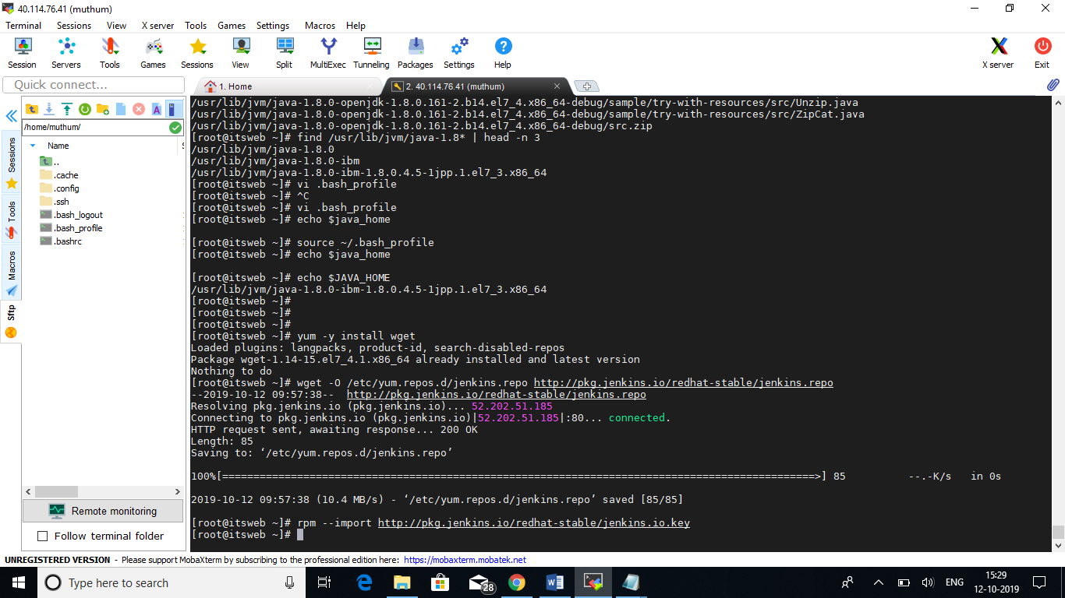

# yum –y install Jenkins

Used to install Jenkins.

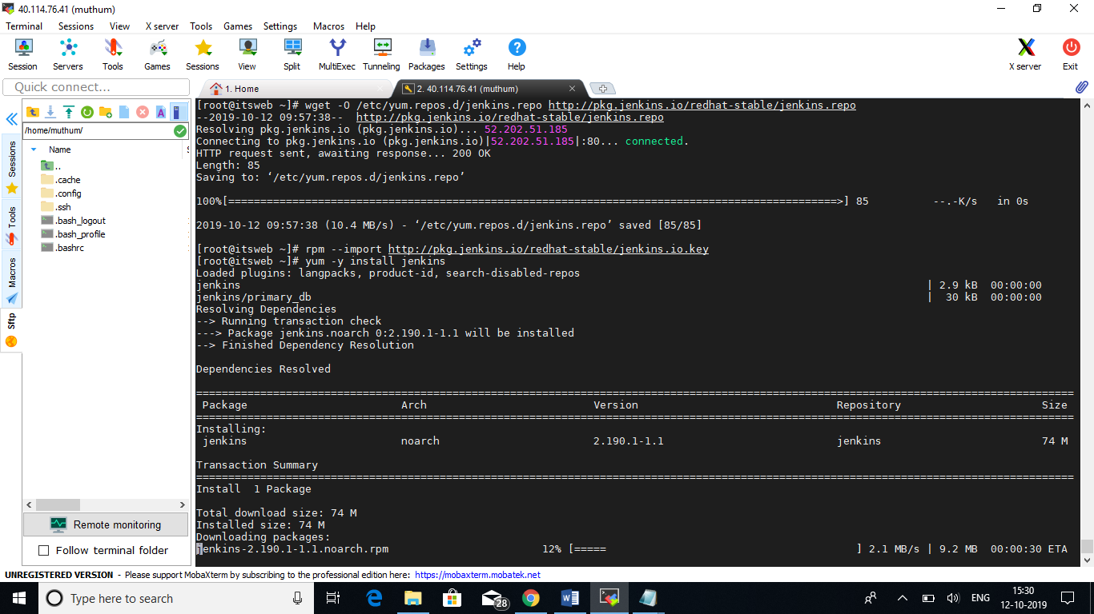

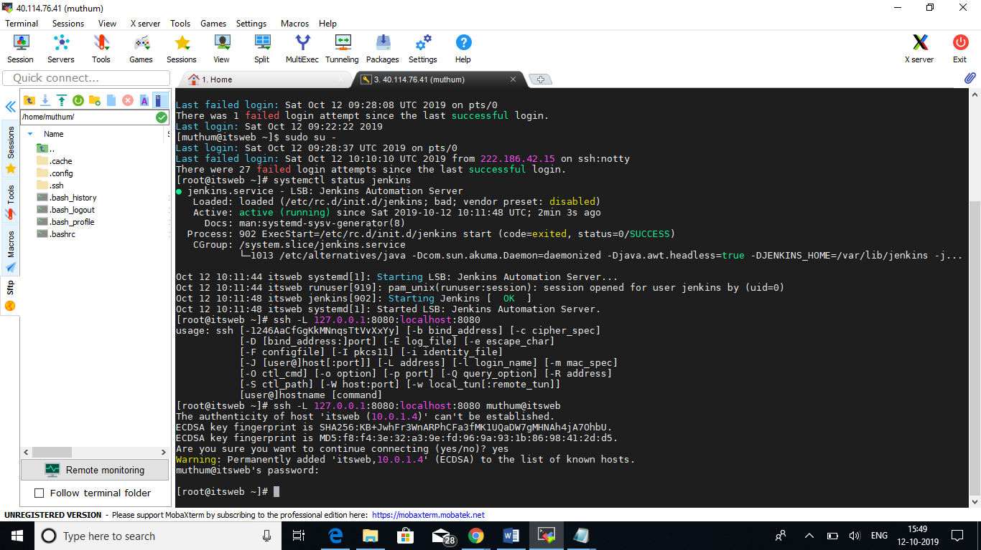

After installing Jenkins, we need to open the required firewall ports in Linux VM or stop the firewall service. Here I am stopping the firewall services of the Linux VM. The Jenkins home page is loaded successfully in the internet.

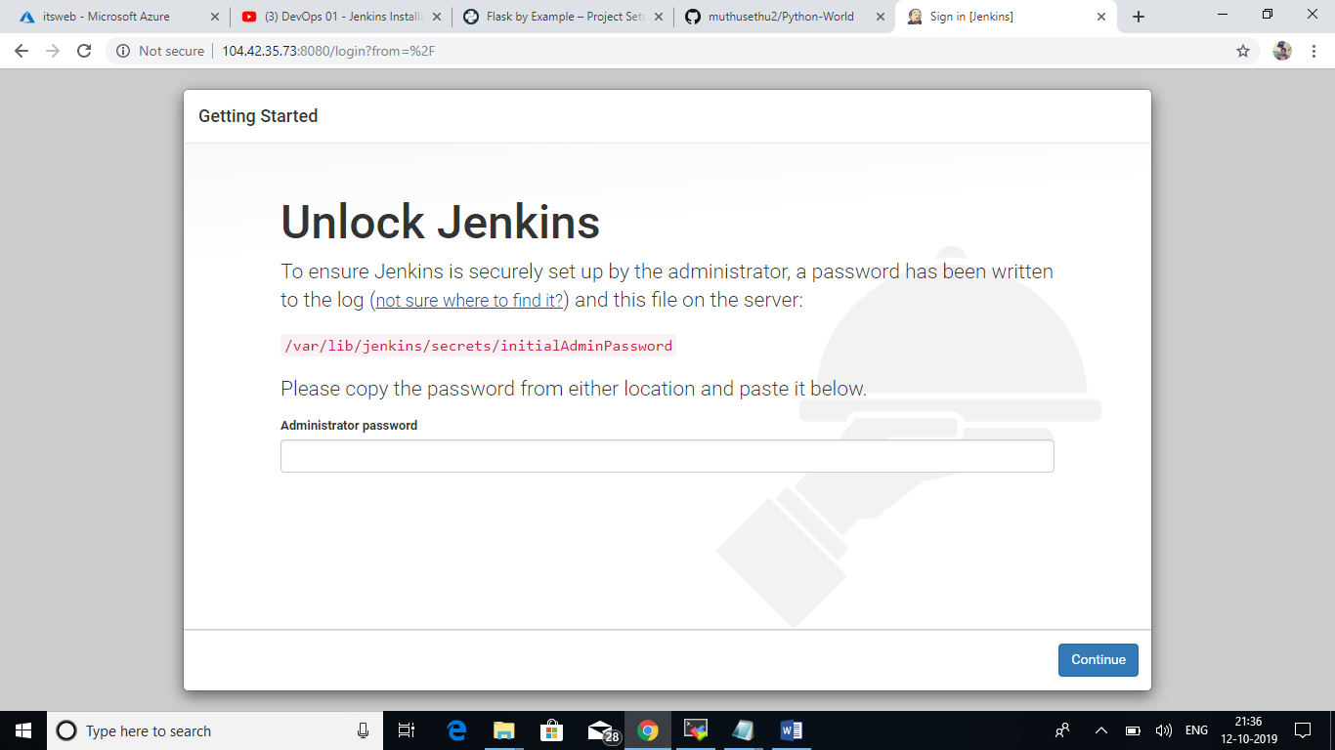

Need to provide default administrator password. We can use the default path to get the password and provide it to the required field.

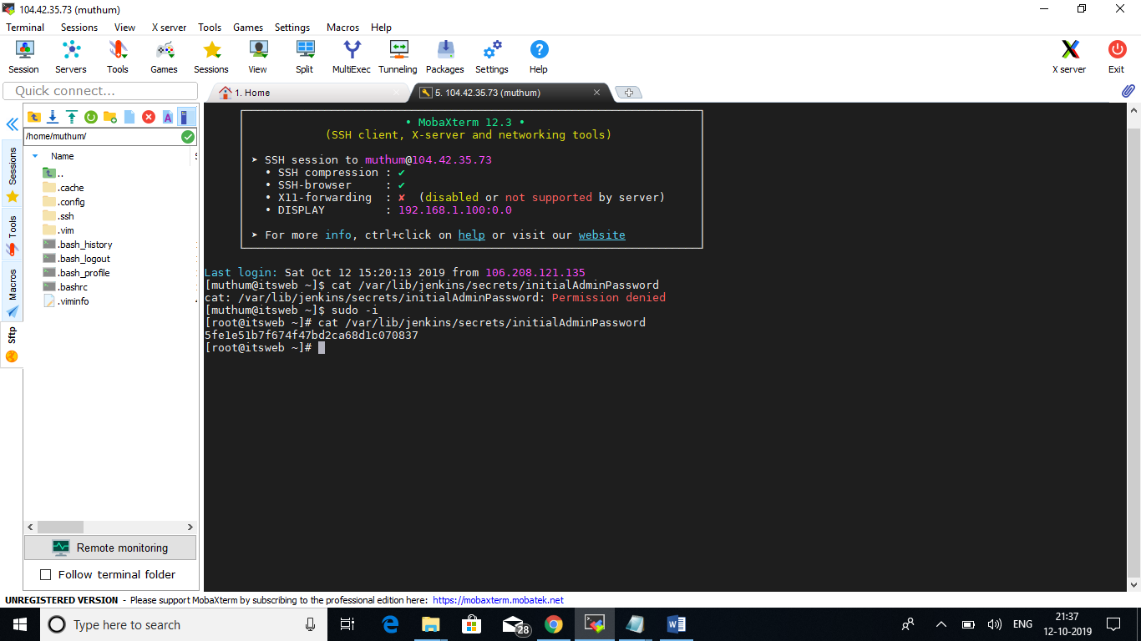

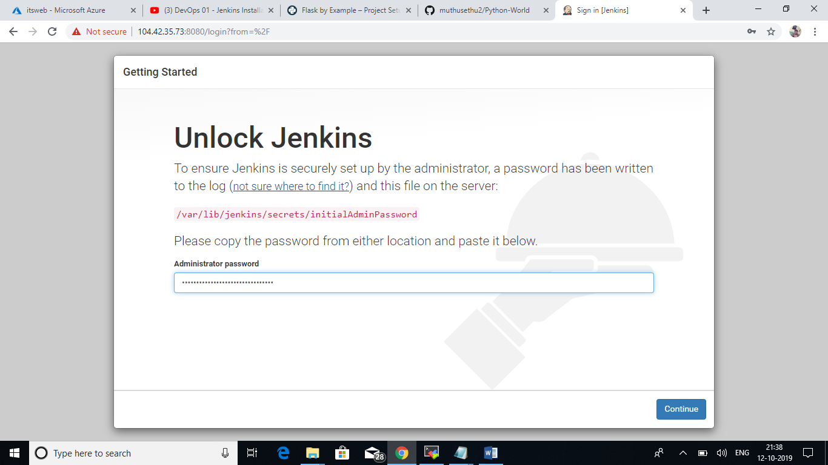

Click Install suggested plugins or select plugins to install later as needed for the requirements.

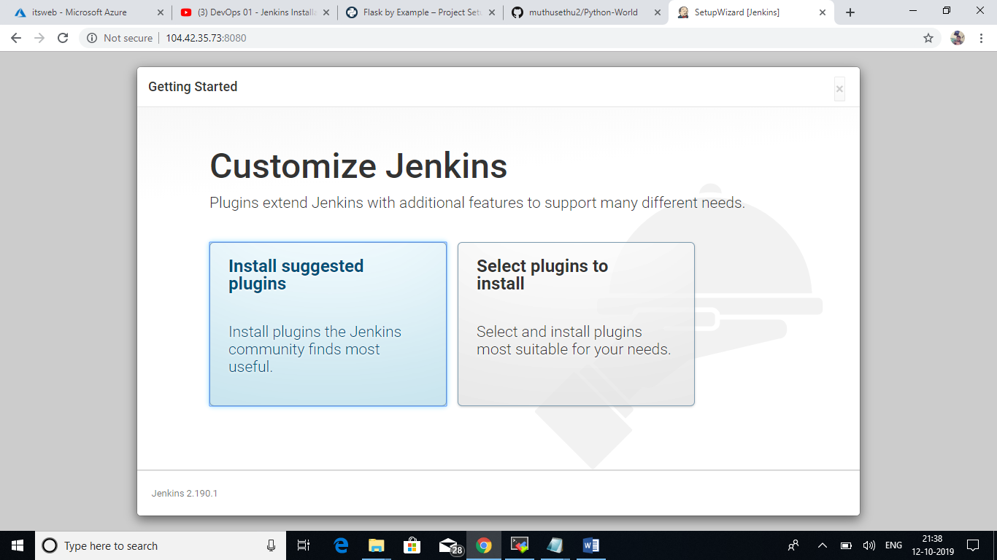

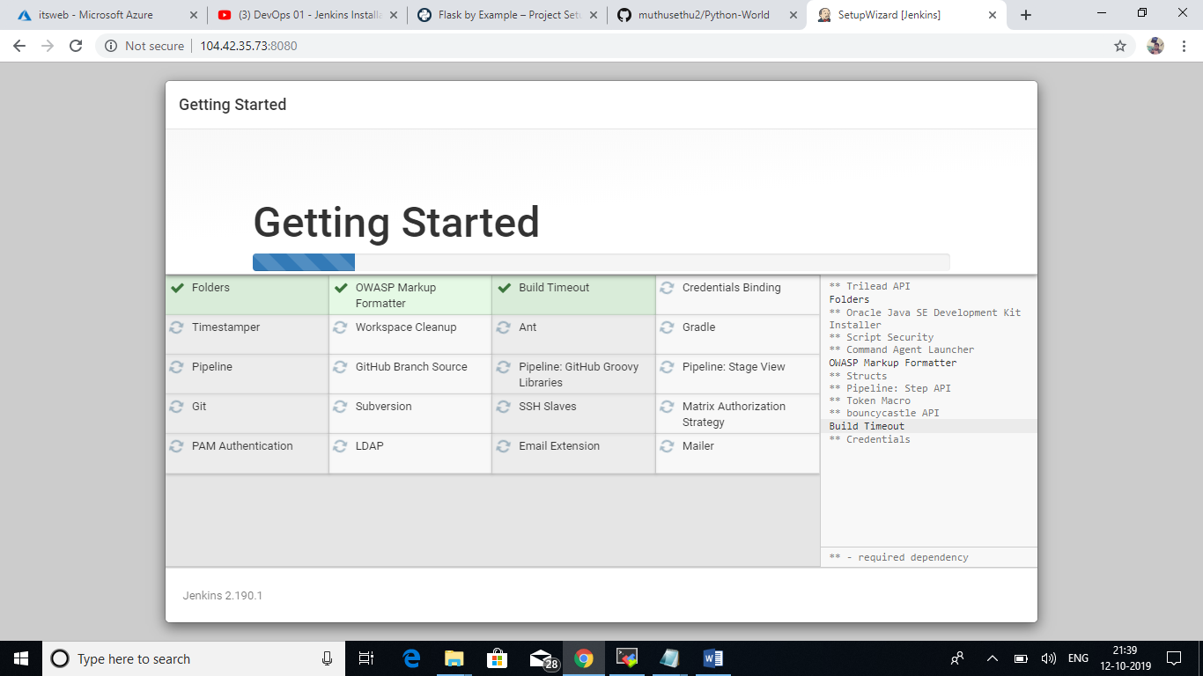

Create Admin User account in Jenkins.

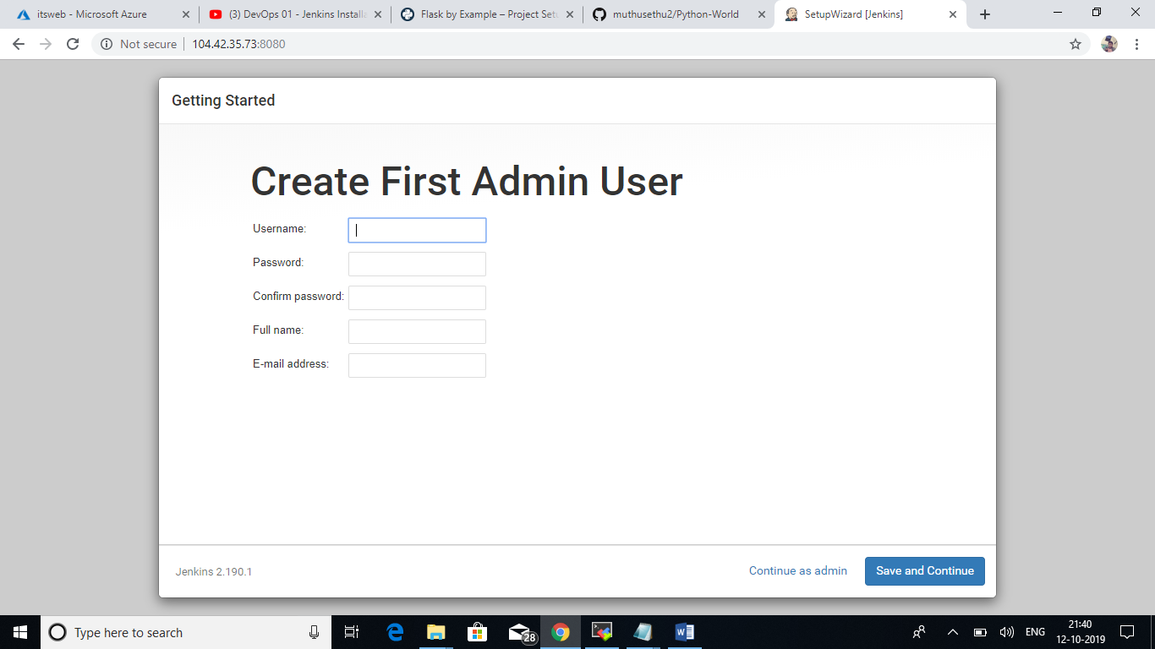

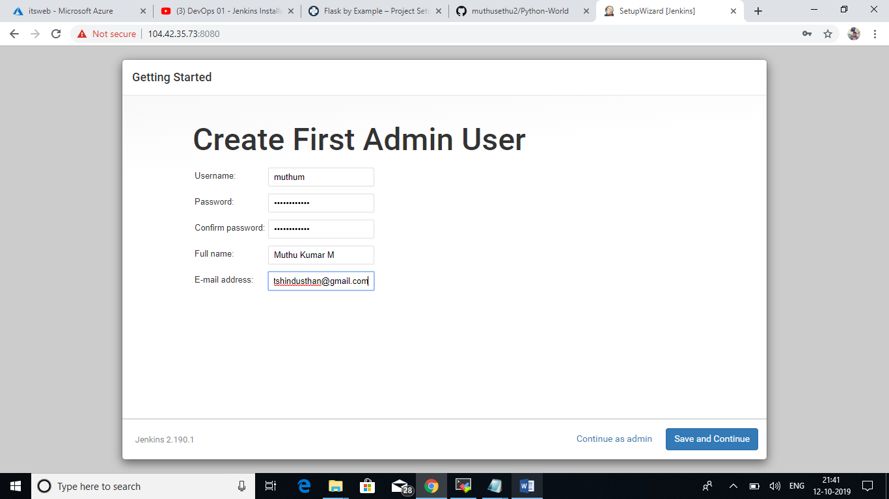

Click Save and Finish.

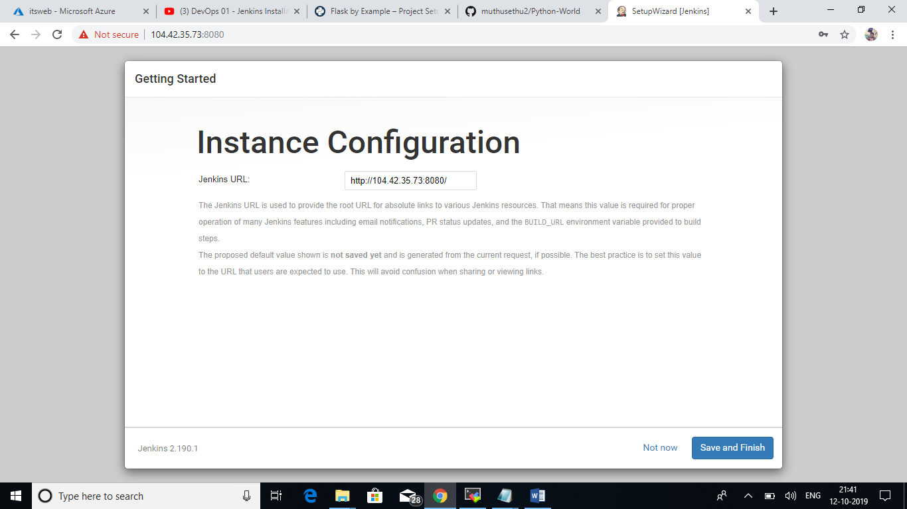

Jenkins is ready to use!!

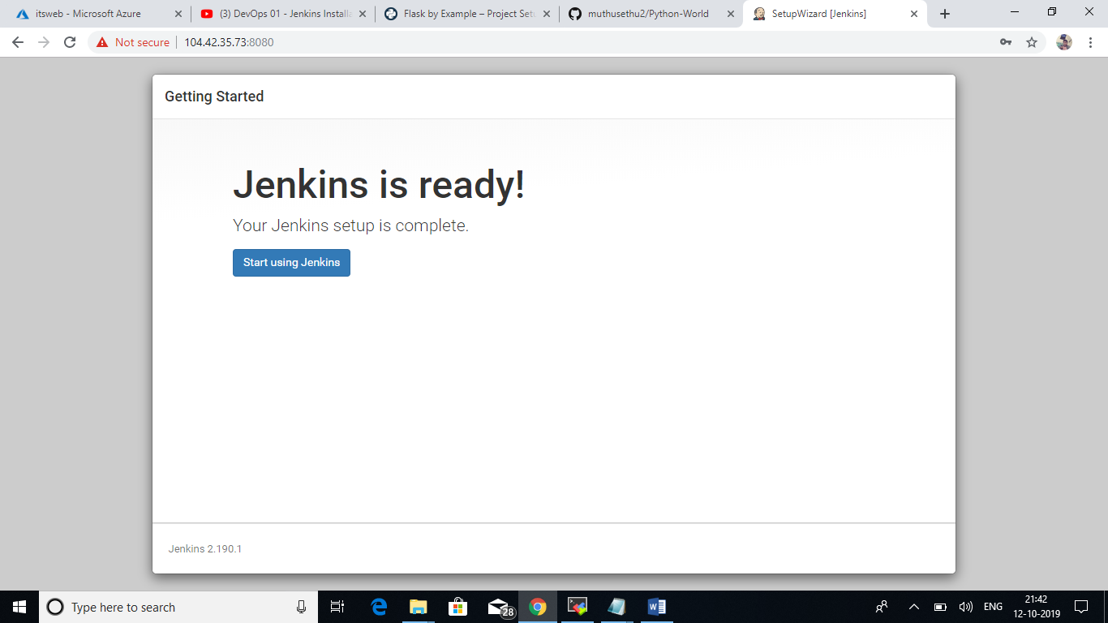

Go to Manage Jenkins🡪Global Tool Configuration

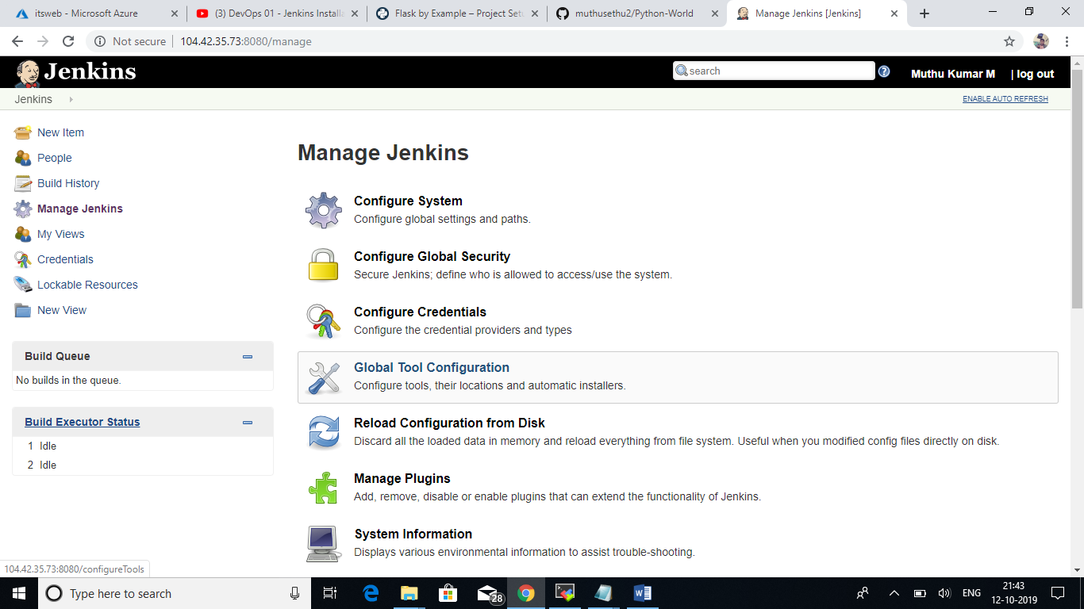

Adding the Java installation path of the Jenkins server in JAVA_HOME field.

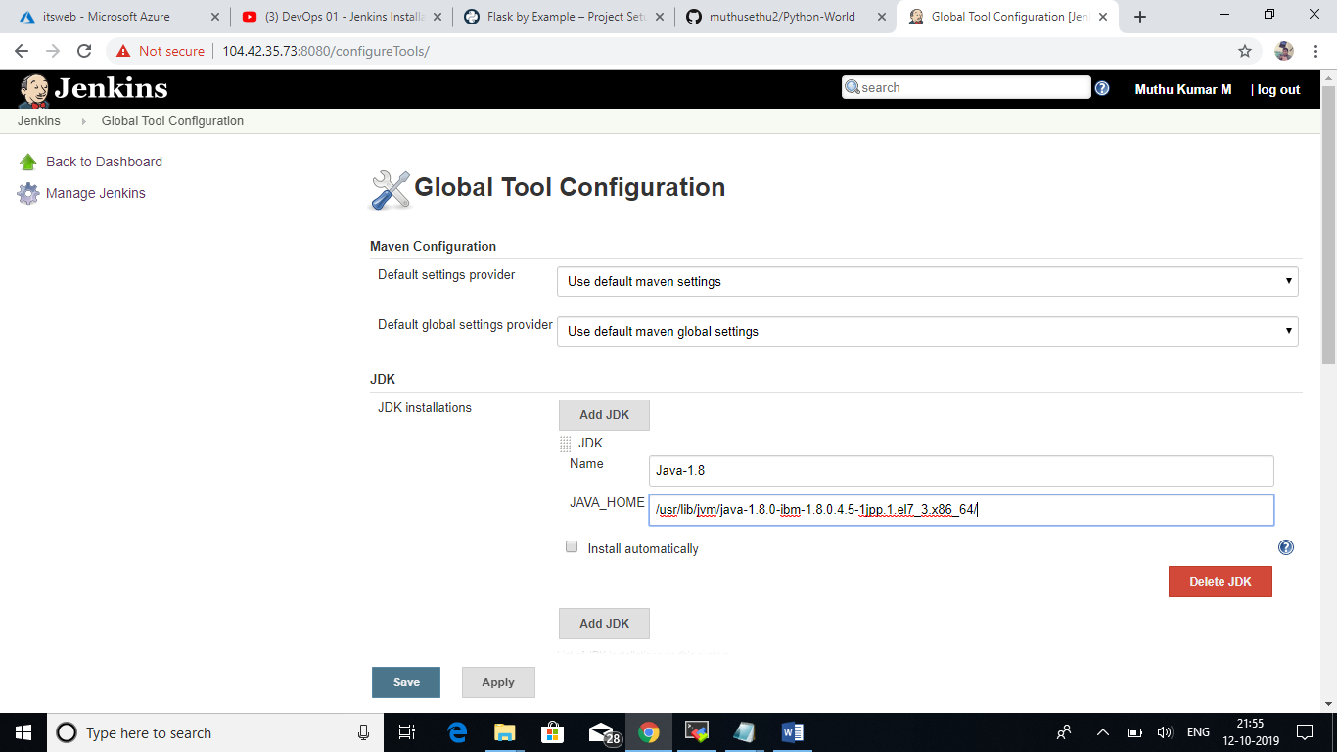

Managing Roles and Users:

Go to Manage Jenkins🡪Manage Users

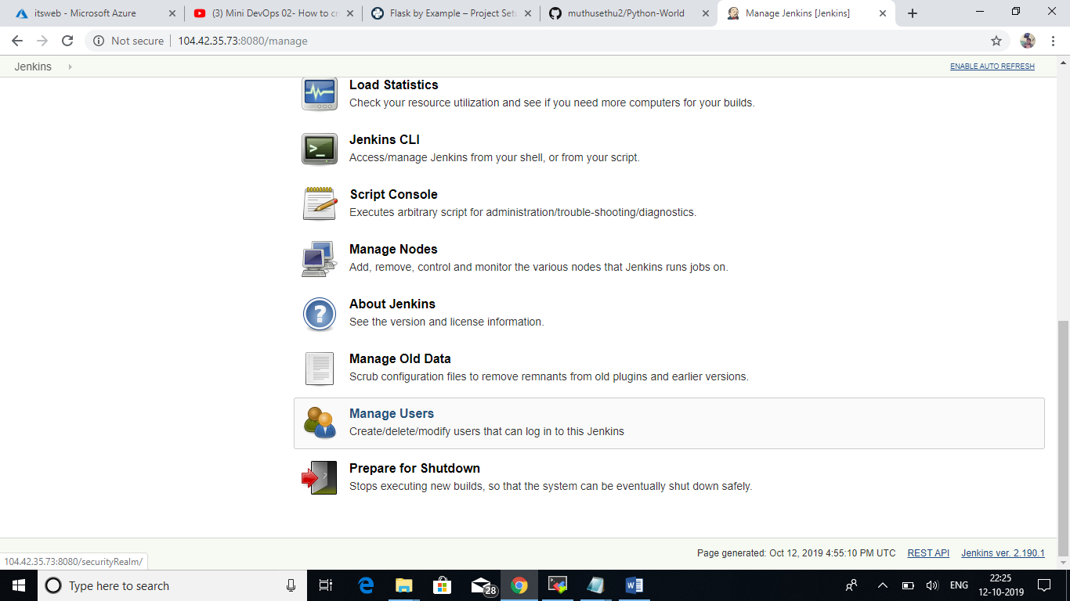

I am creating two different user accounts “Dev for developer and Test for Tester”.

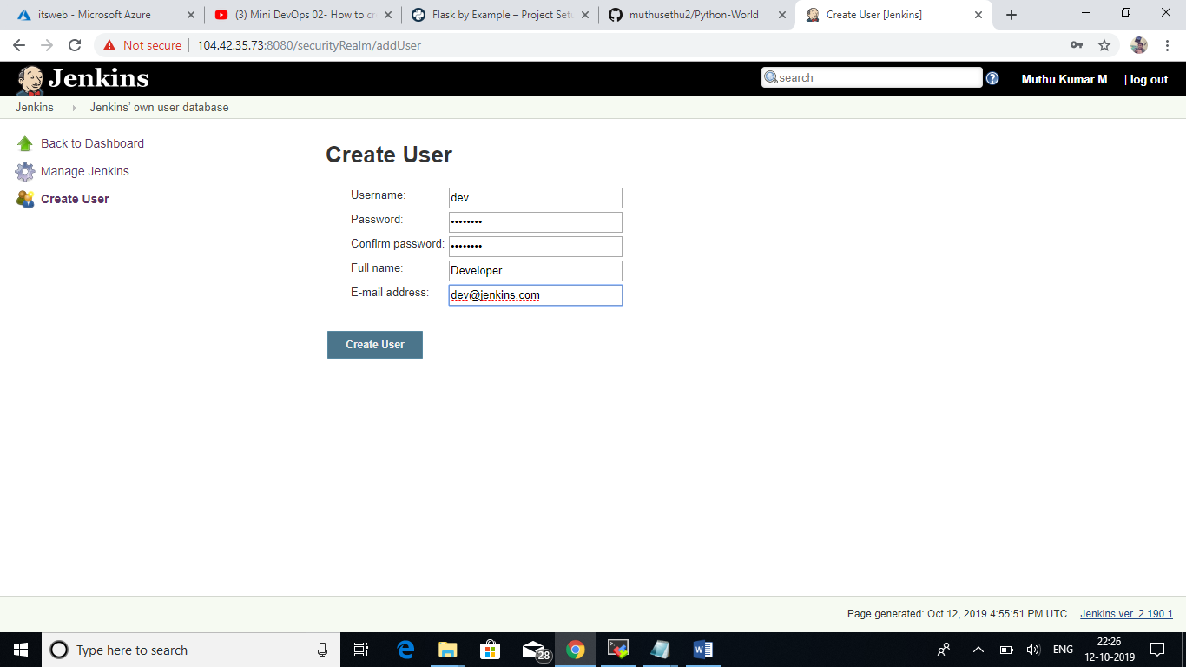

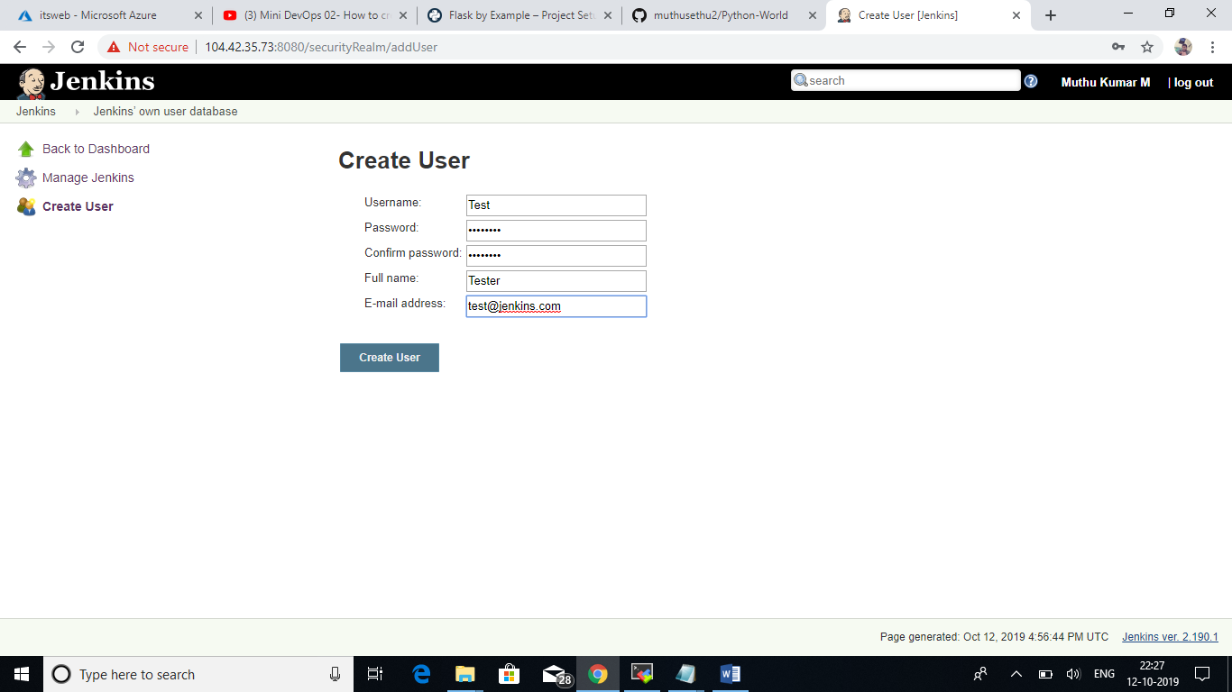

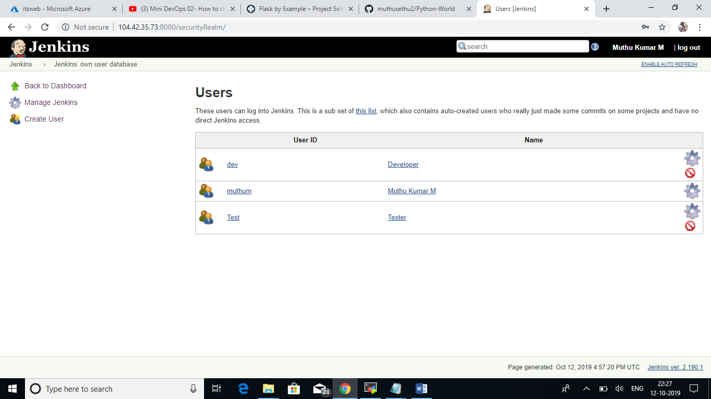

Go to Manage Jenkins🡪Configure Global Security

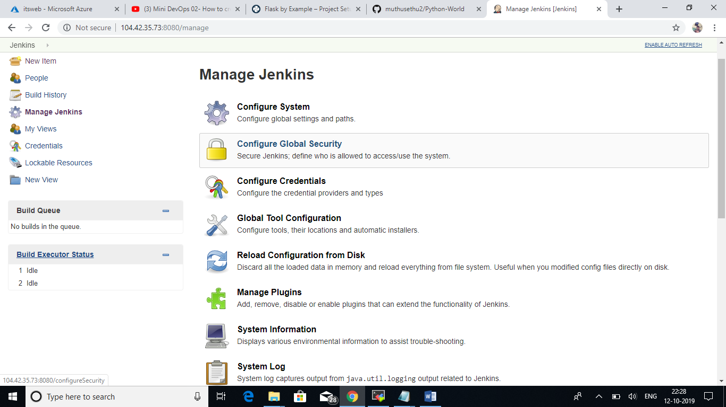

No options for role based access control. We need to install and enable a plugin for role based access.

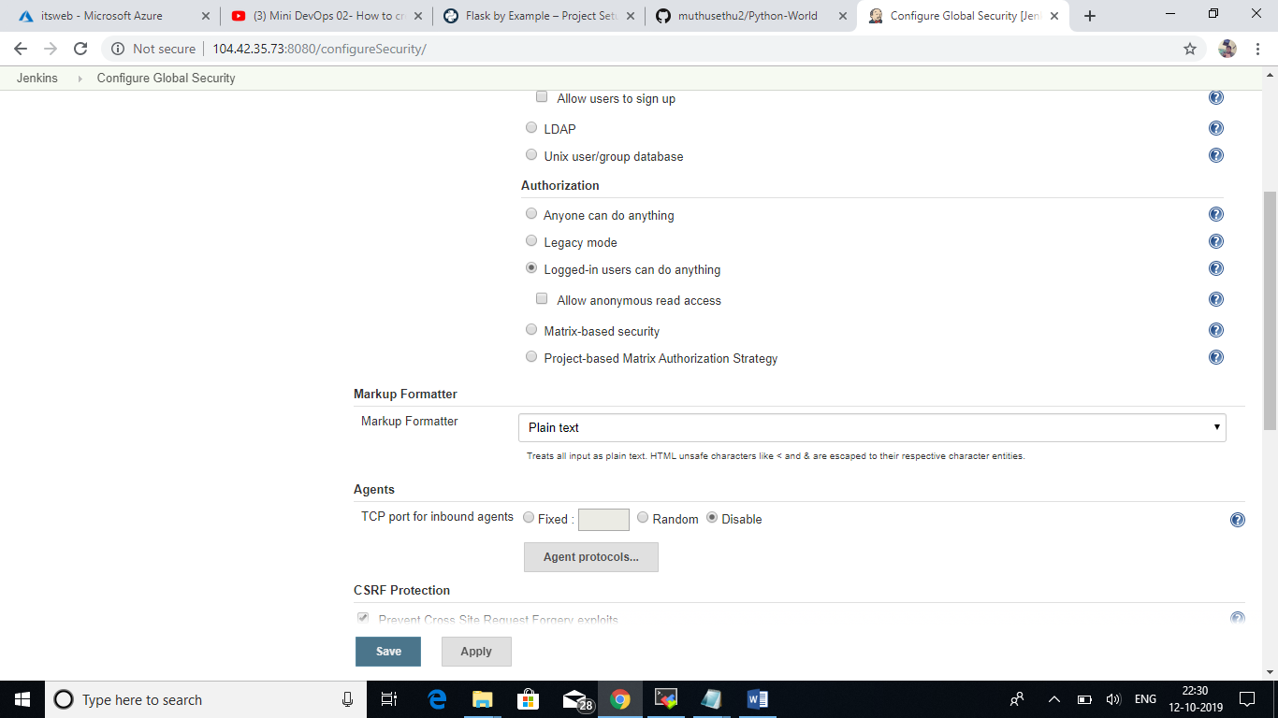

Go to Manage Jenkins🡪Manage Plugins

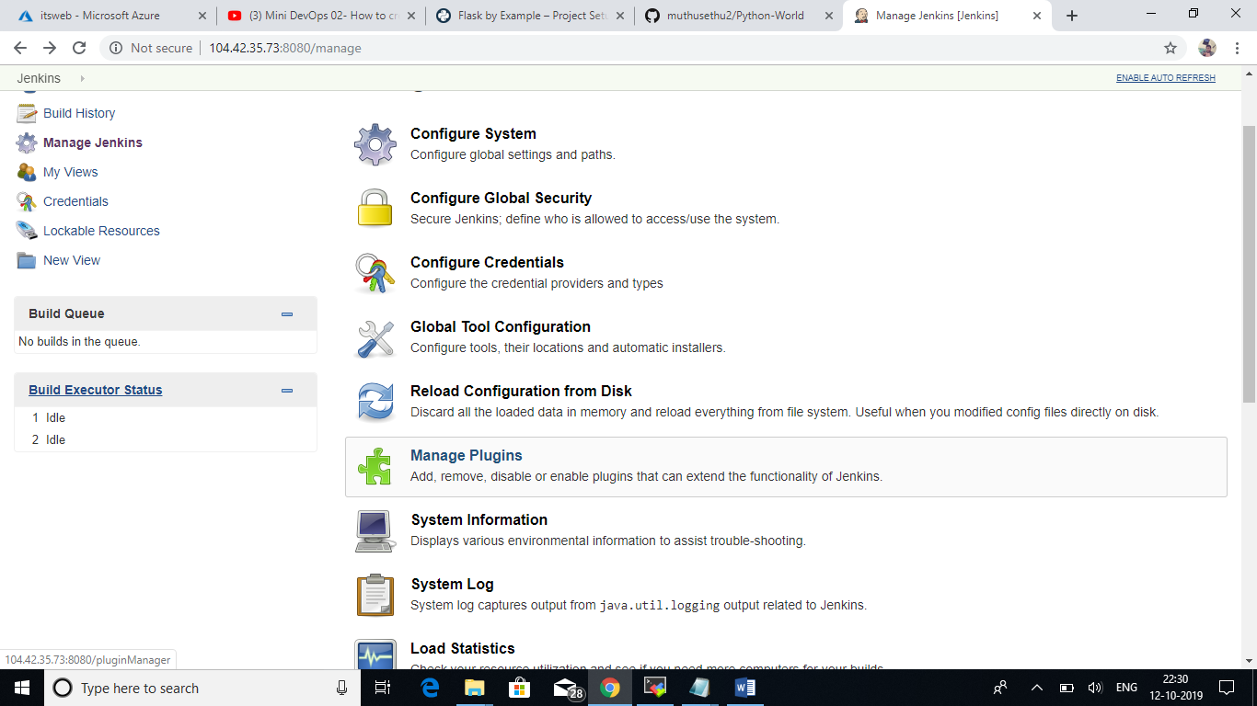

Search Role-based Authentication Strategy plugin in available tab. Check the box and install the plugin to get role based access control.

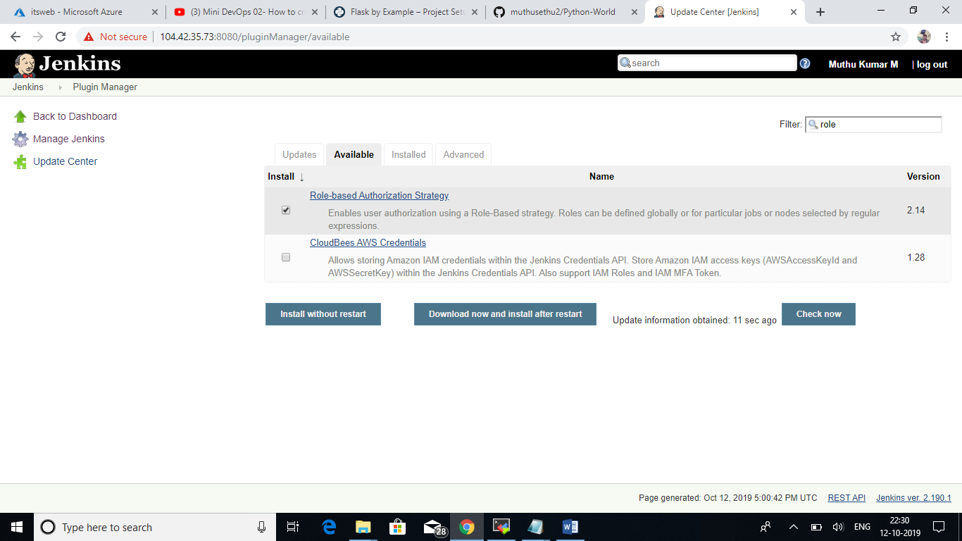

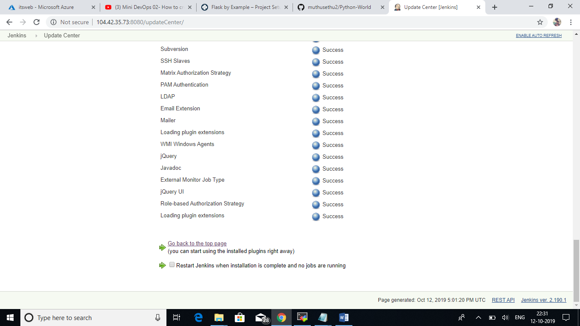

After successful installation we can able to see the Role Based Strategy in authorization.

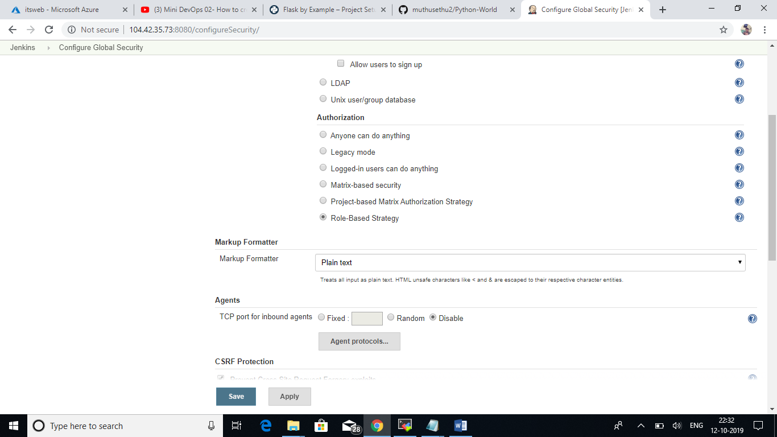

Go to Manage Jenkins🡪Manage and Assign Roles

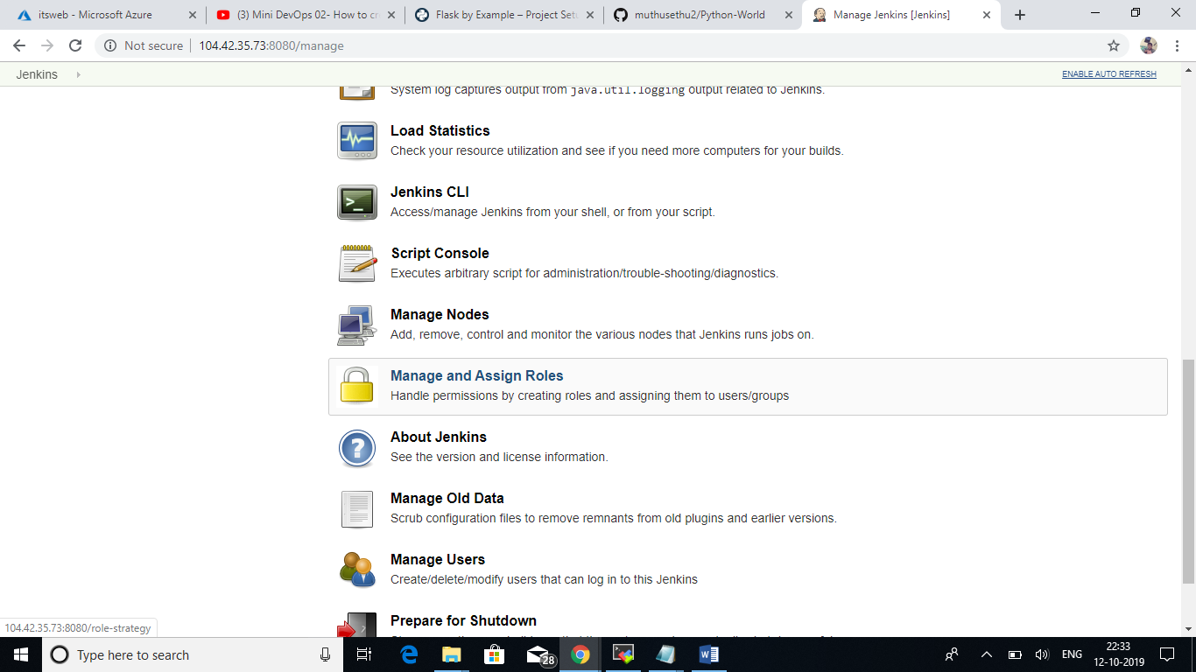

There is an options like Manage Roles, Assign Roles and Role Strategy Macros.

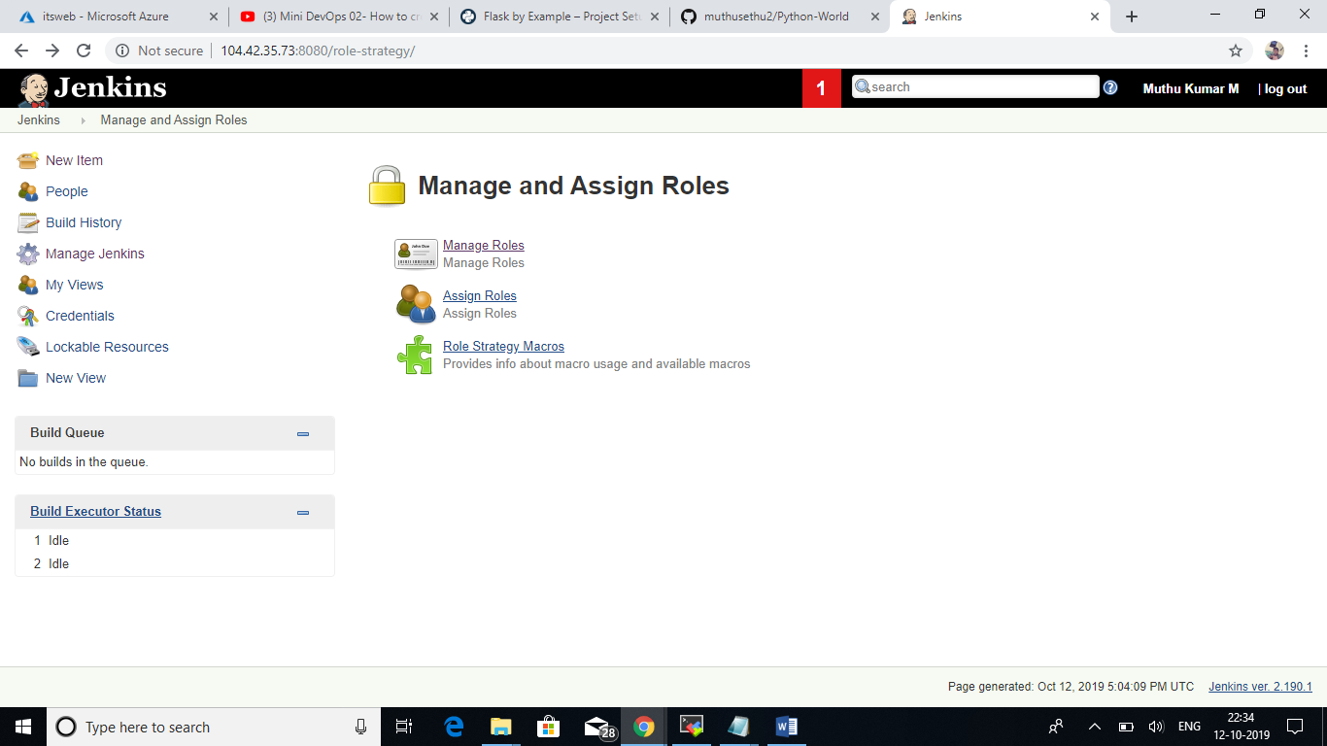

In Manage Roles, we have different options like Global roles, Project roles, Slave roles. Here I have created one Global role and two project role as in the picture below.

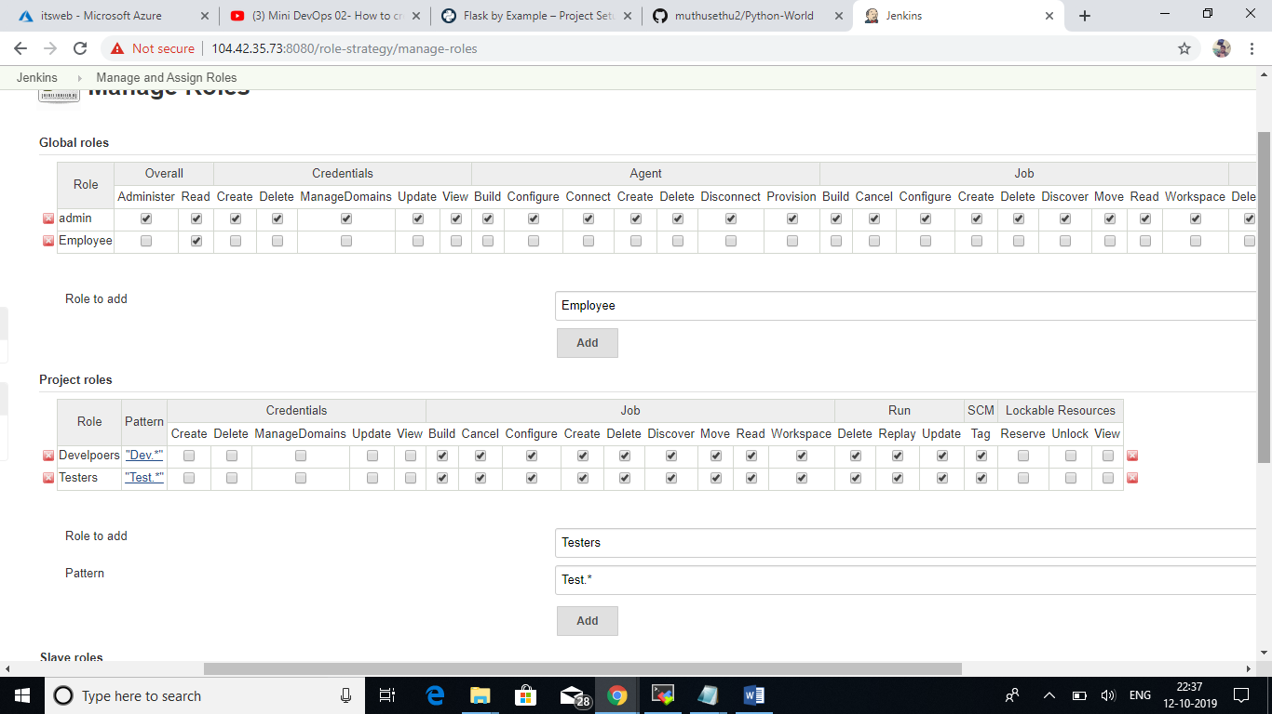

In Assign Roles, I have assigned the roles which is created in the previous steps to the users as in the below picture.

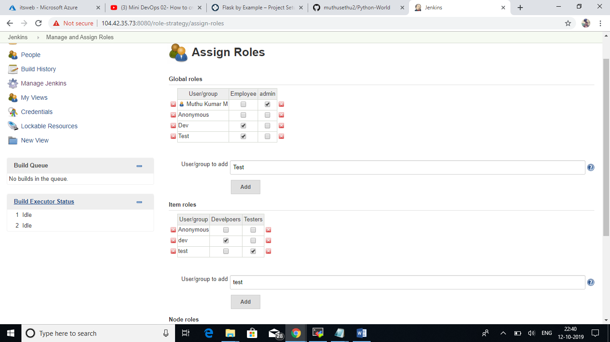

Created two test projects for testing the user accounts and roles.

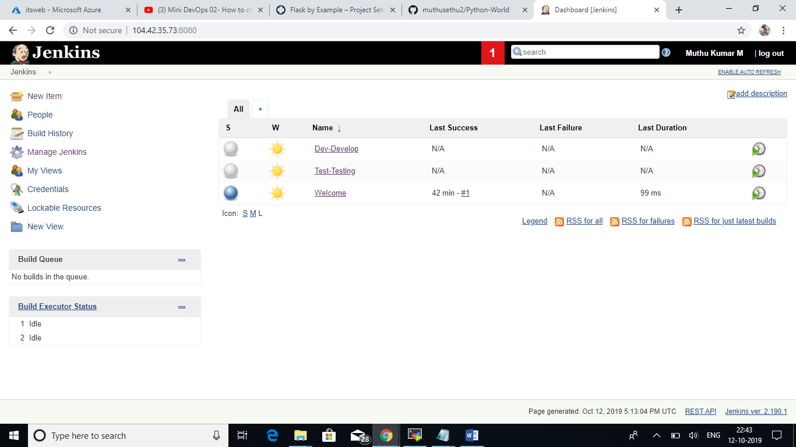

Maven Installation:

We are going to install Maven (Project management tool) in the same Jenkins server.

* Created a new directory for Maven Installation.
* Go to the directory and download the Maven Package.

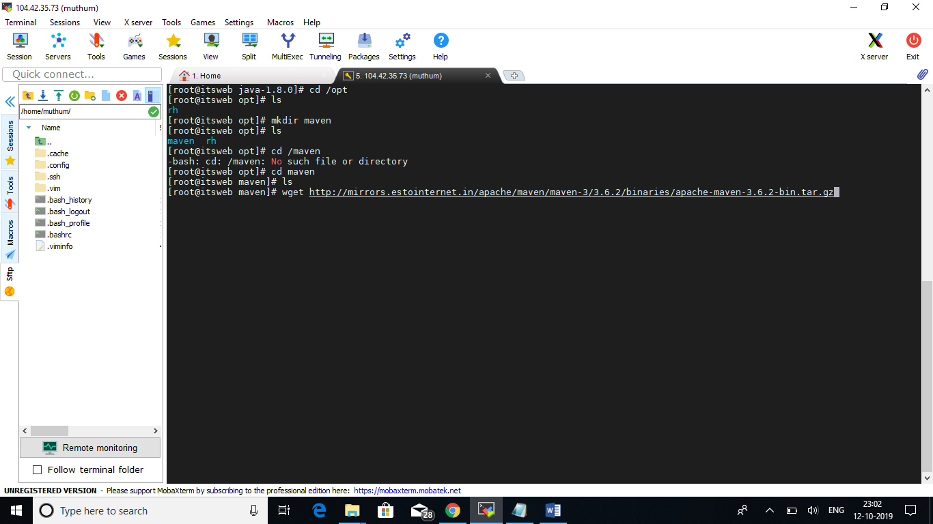

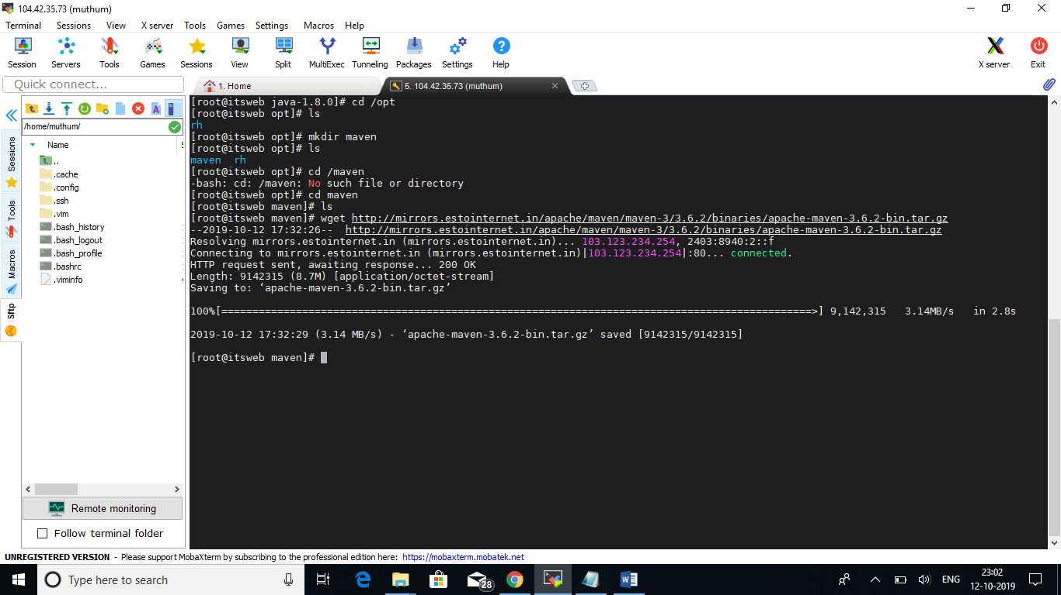

Once downloaded, extract the file and install the Maven in the Jenkins Server.

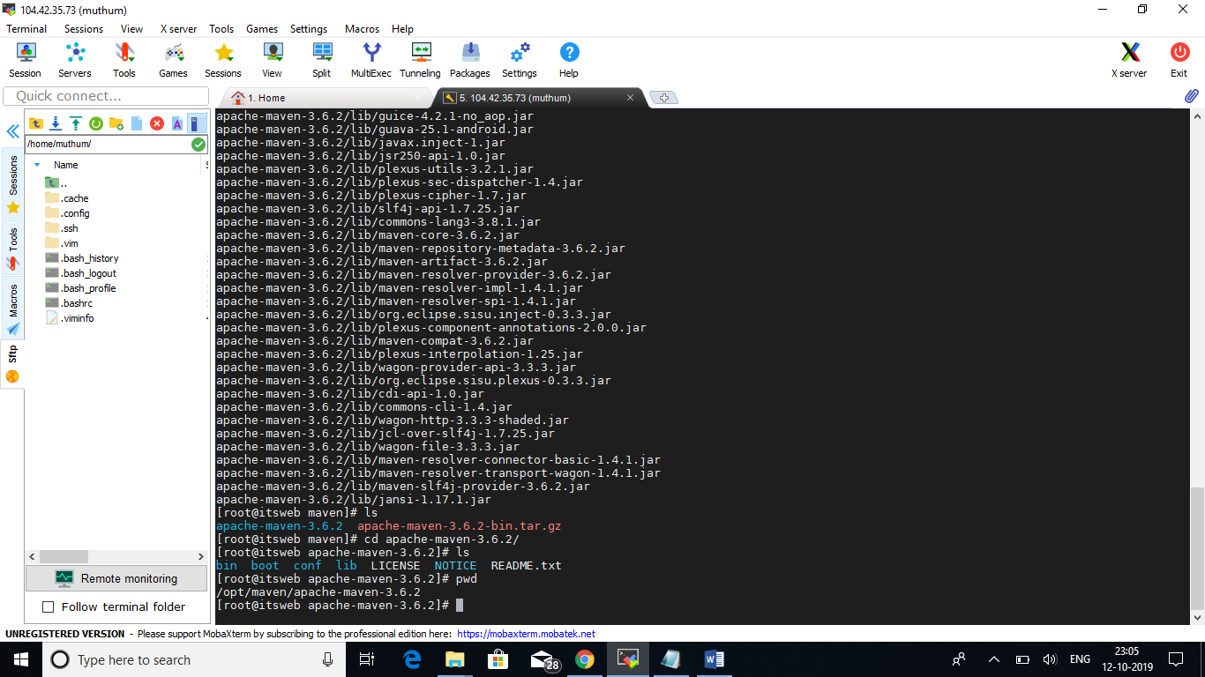

Setup the installation PATH for Maven helps to integrate with Jenkins.

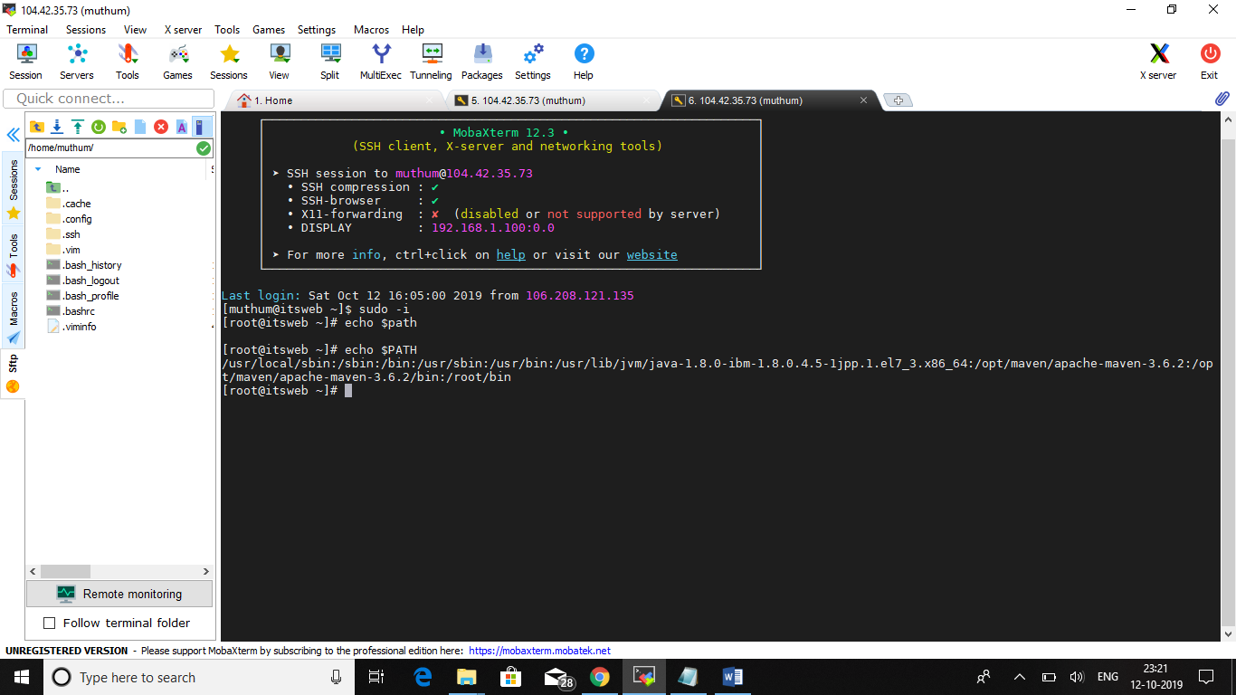

Integrate Maven with Jenkins.

Go to Manage Jenkins🡪Manage Plugins

Search Maven Invoker plugin for Maven integration in the Jenkins.

Setup the PATH for Maven in the Jenkins Global Settings as we did for JAVA_HOME.

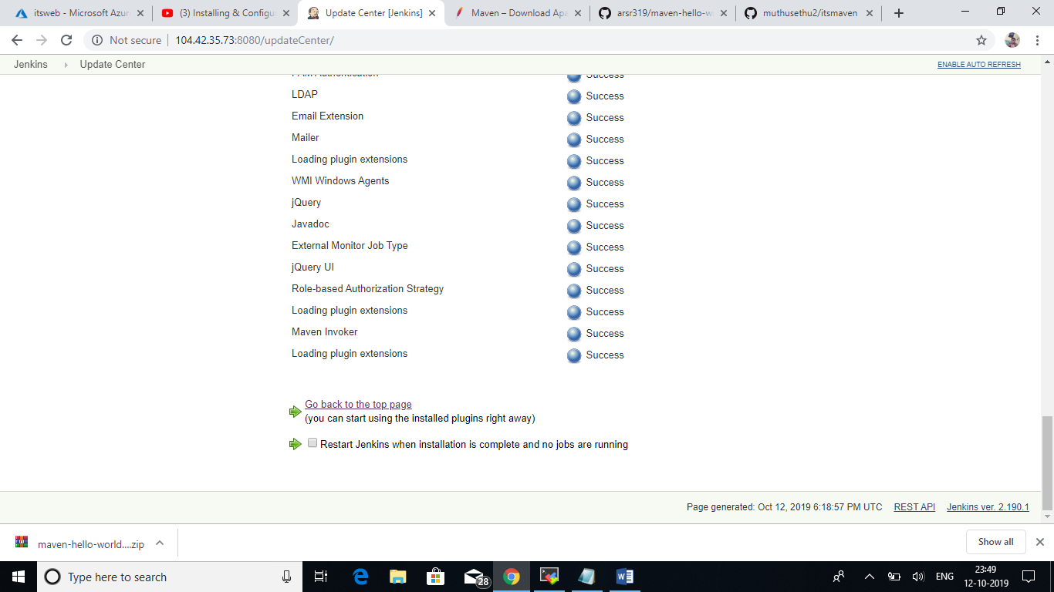

Maven Project Creation:

We need to install Unleash Maven Plugin in plugin management to create Maven Project.

Go to New Item🡪Enter Project Name🡪Select Maven Project🡪Click OK

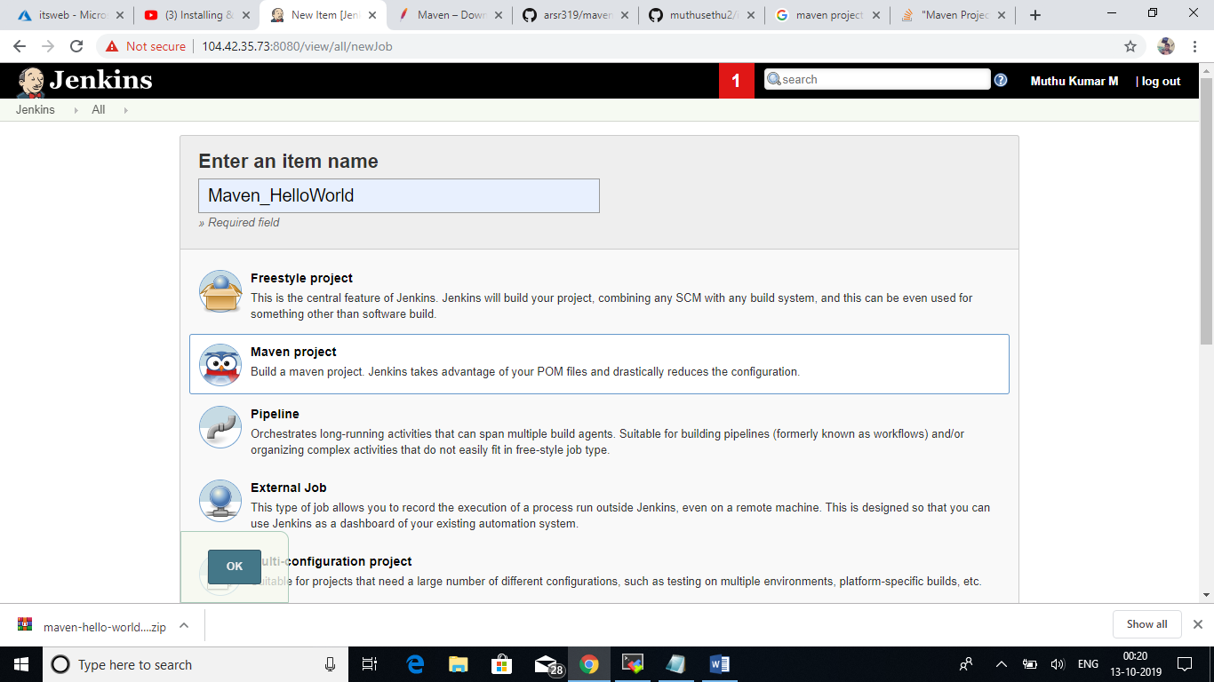

In Source Code Management(SCM), provide our GitHub repository URL.

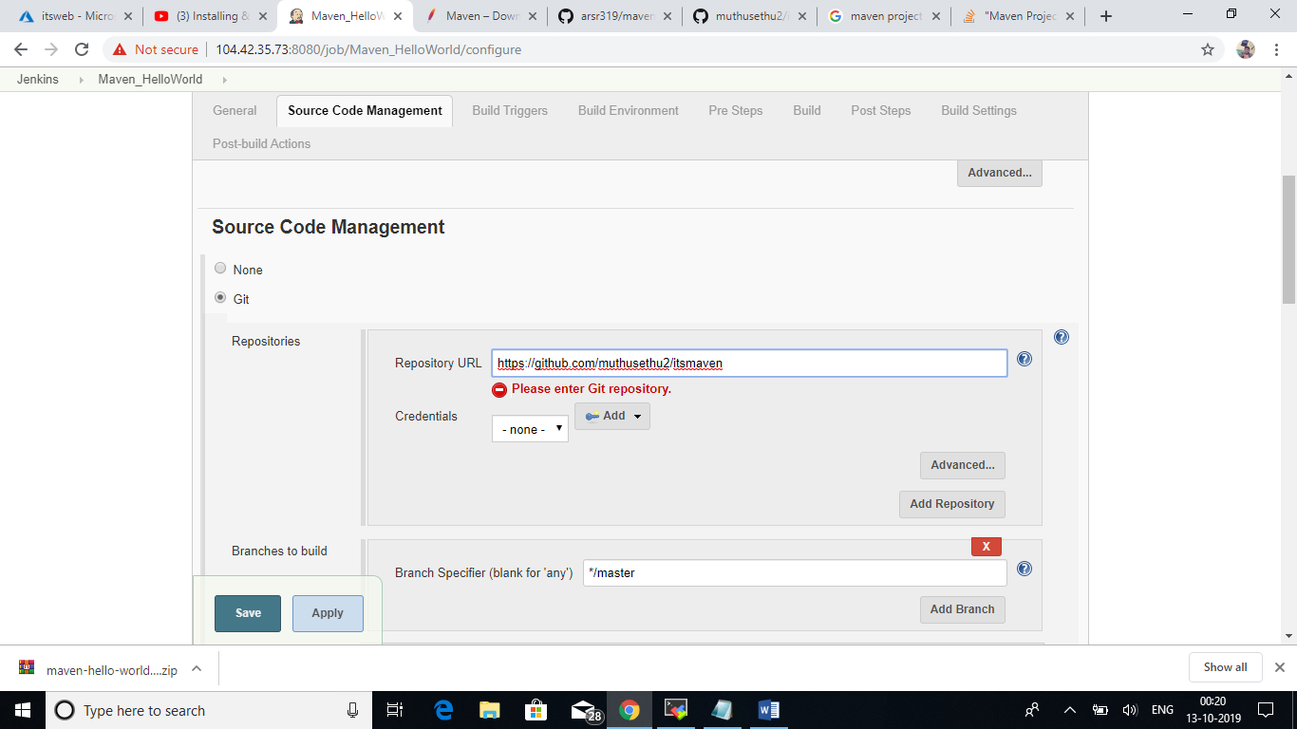

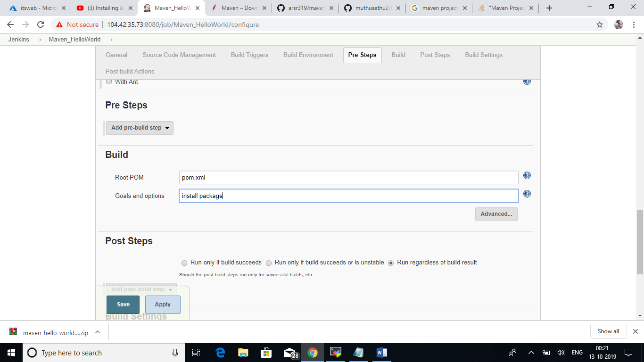

Maven Project Created.

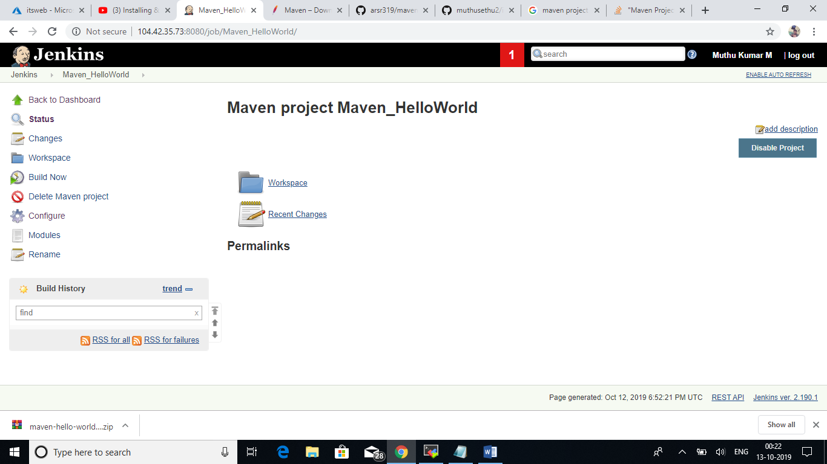

Click Build Now option to build the project.

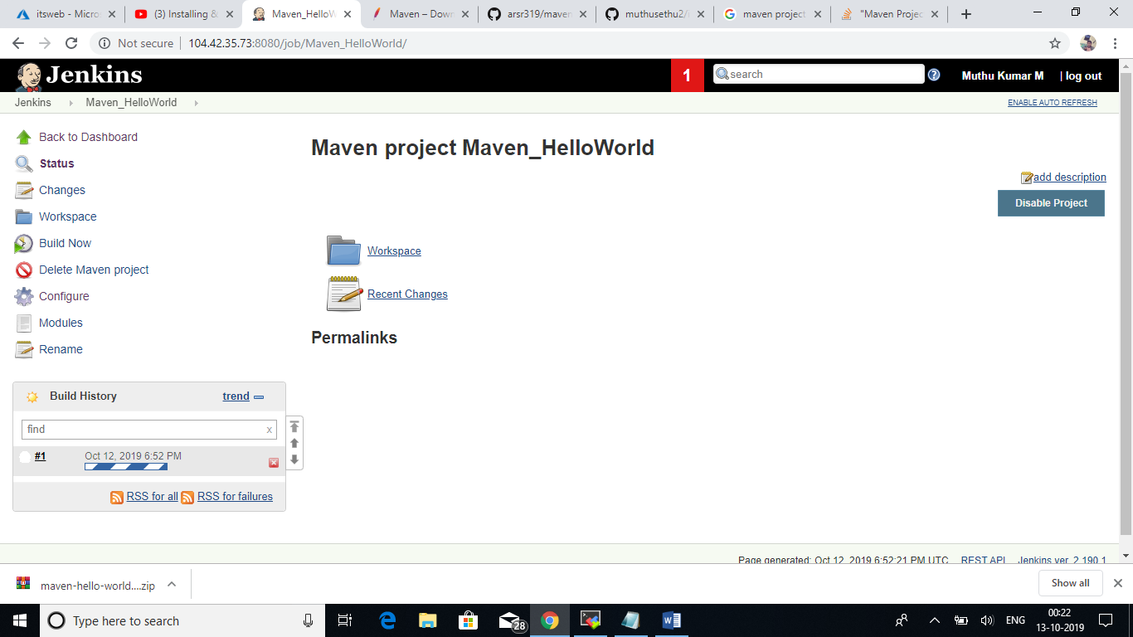

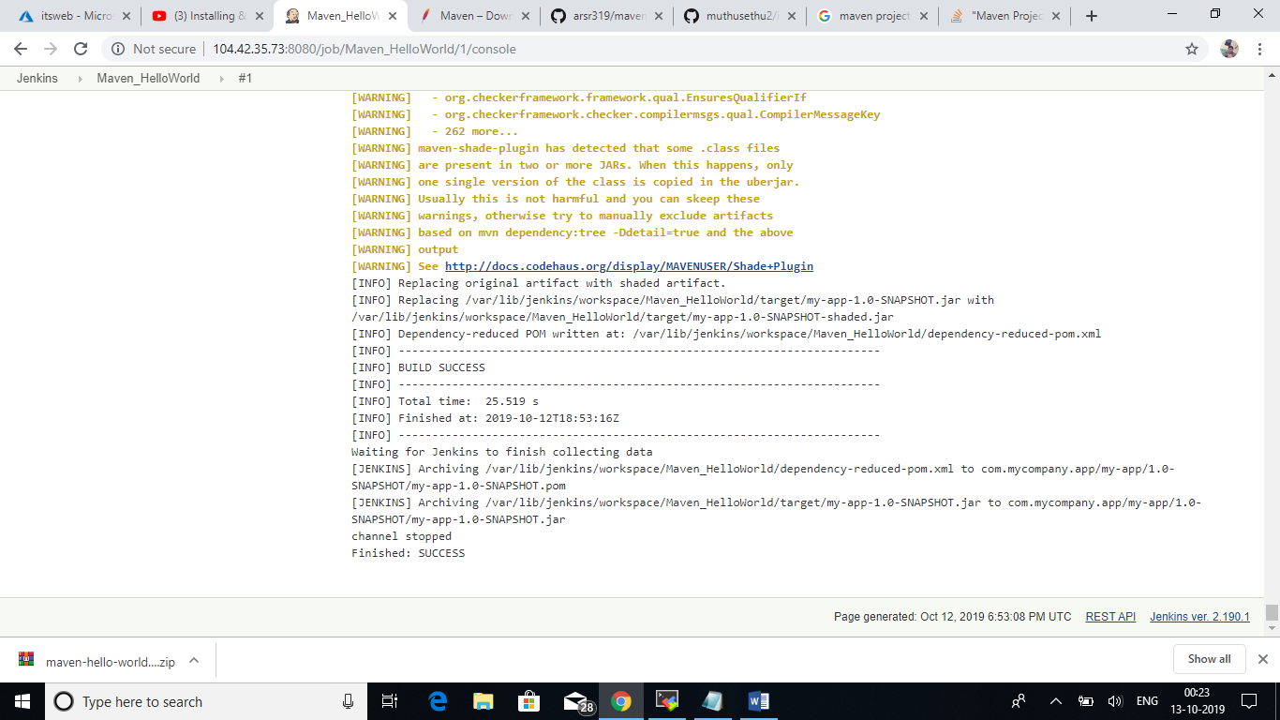

Created one more Red Hat Server for Host Web Server (Tomcat). Installed and configure a Tomcat server in the Linux machine.

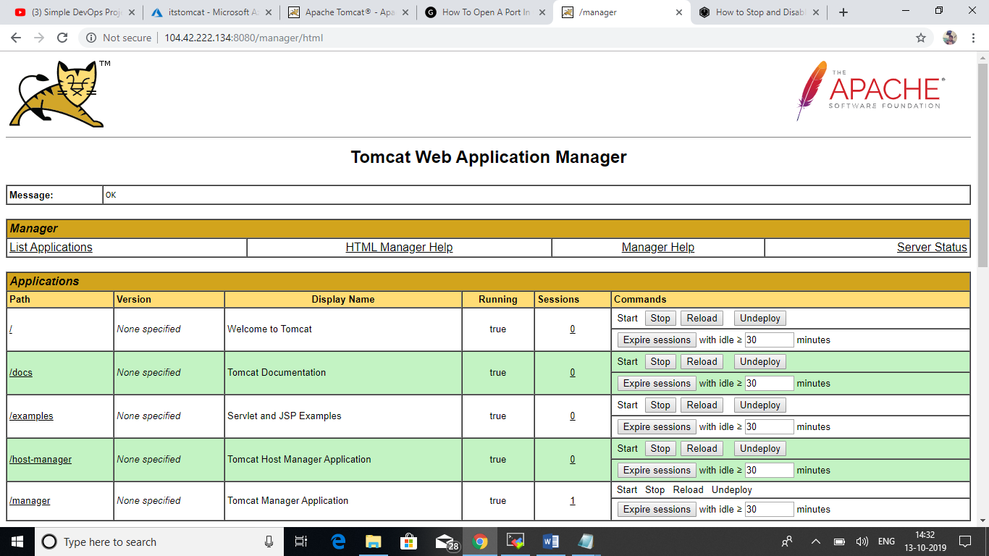

We have created a new repository in GitHub in the name of CI_Helloword for continuous demo.

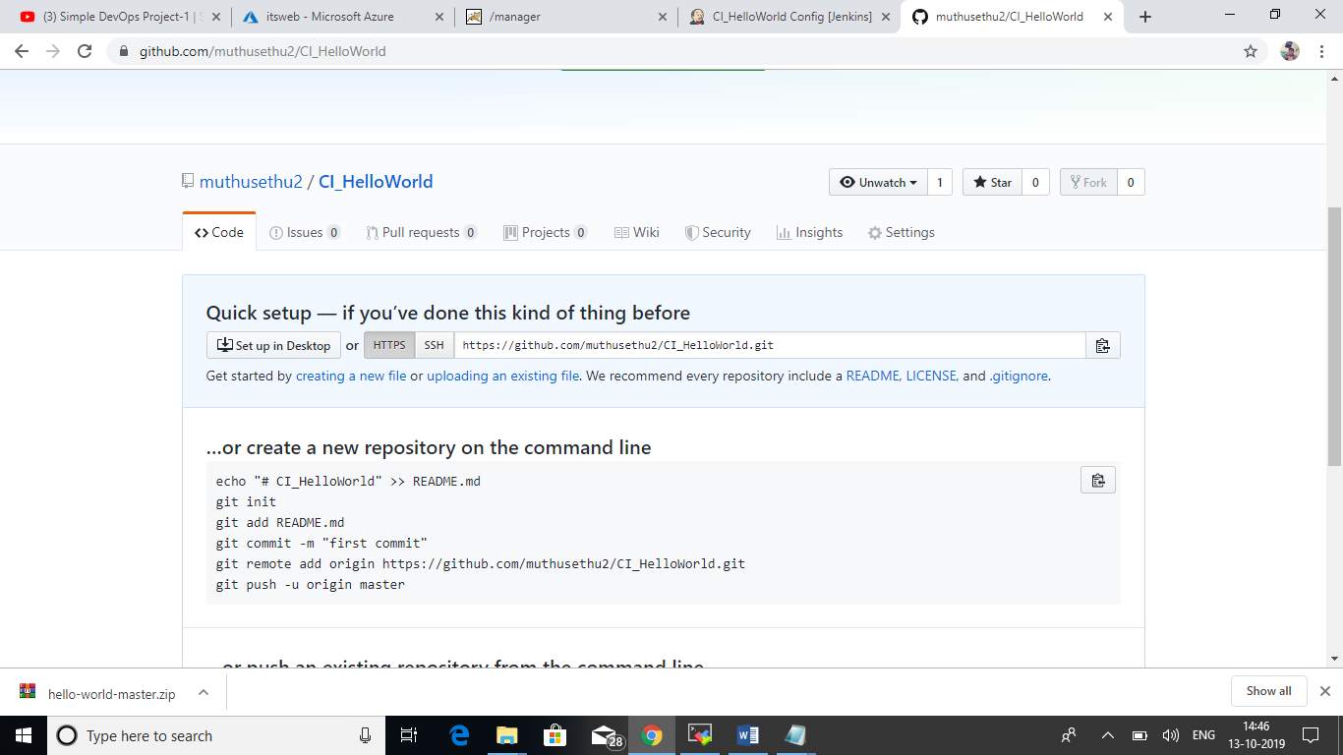

Uploaded the required project files in the repository and committed the changes.

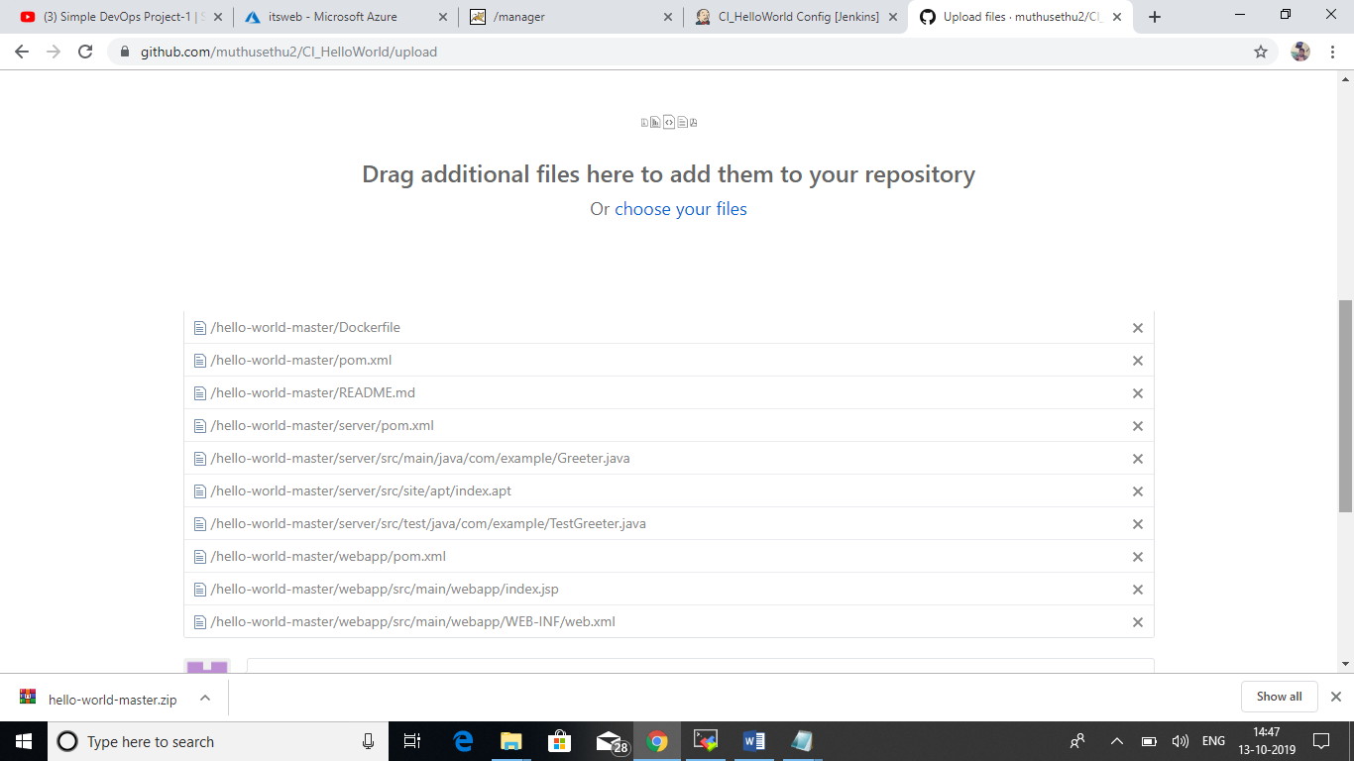

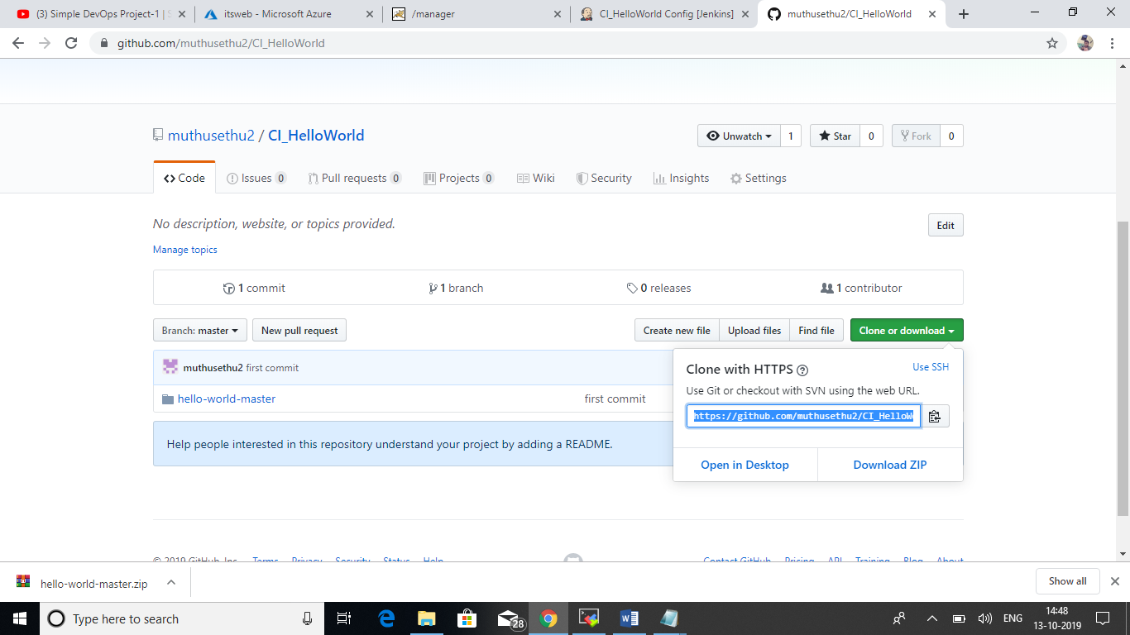

Created New Jenkins Project in the name of CI_Helloworld.

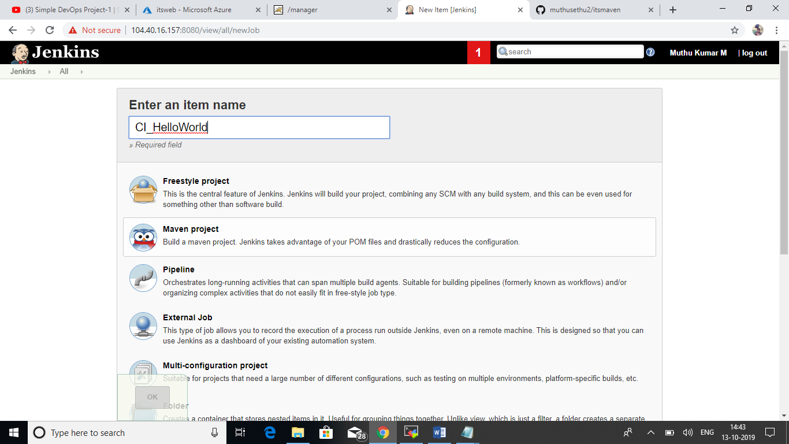

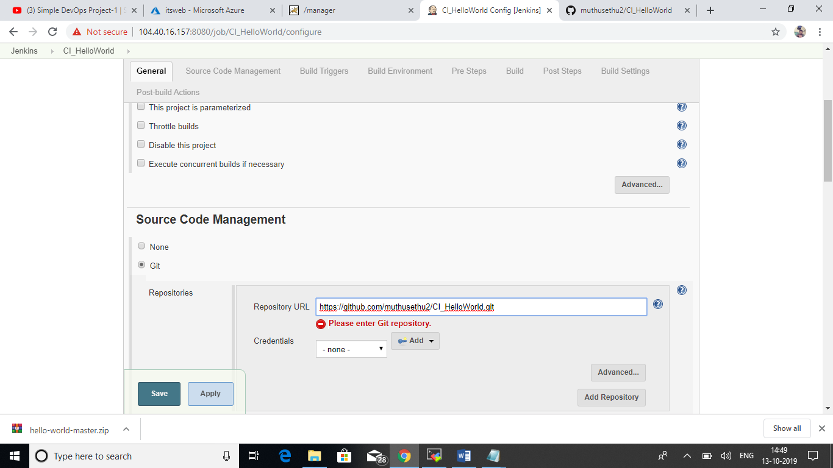

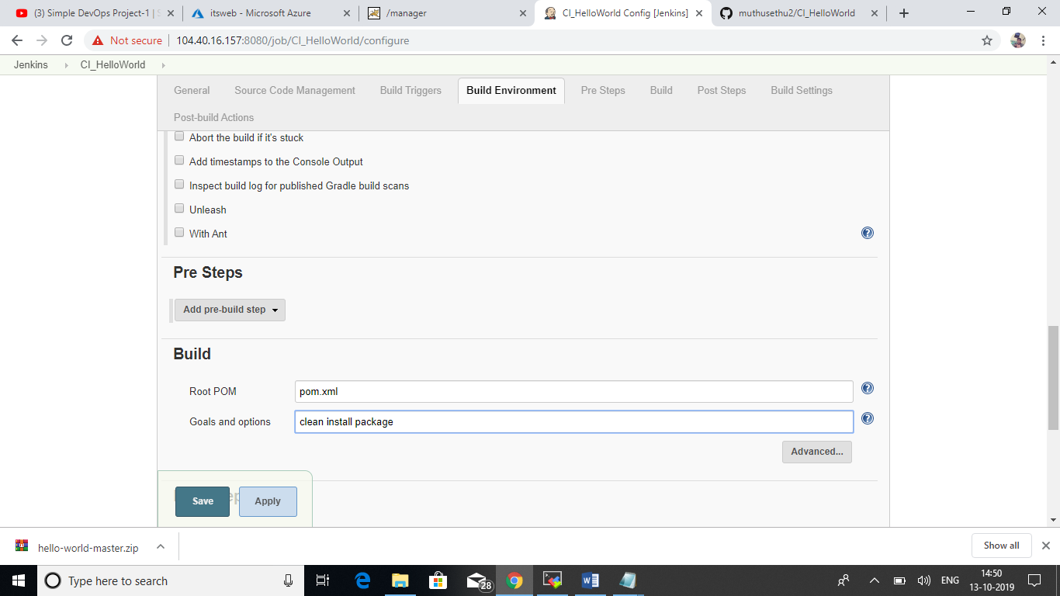

After created the project click the build now option to build the project.

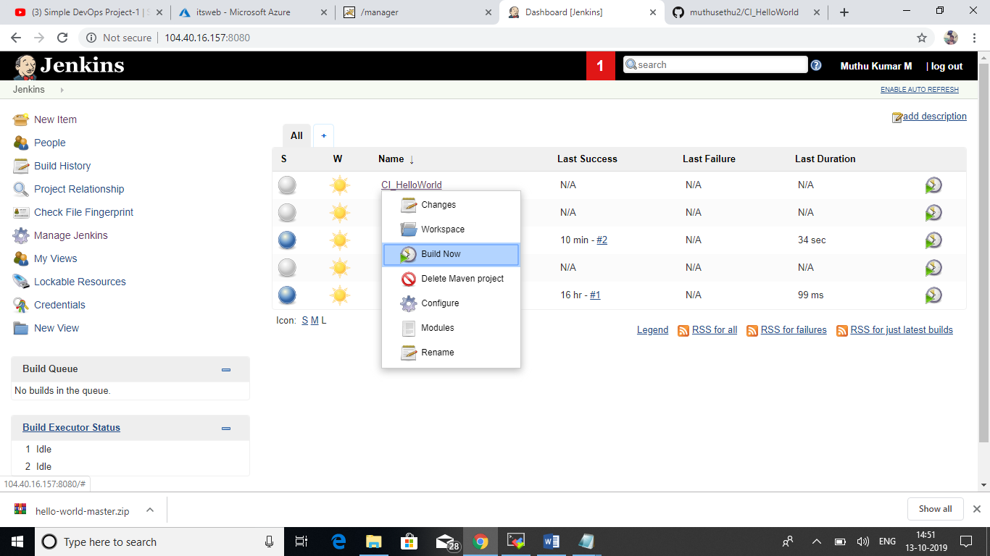

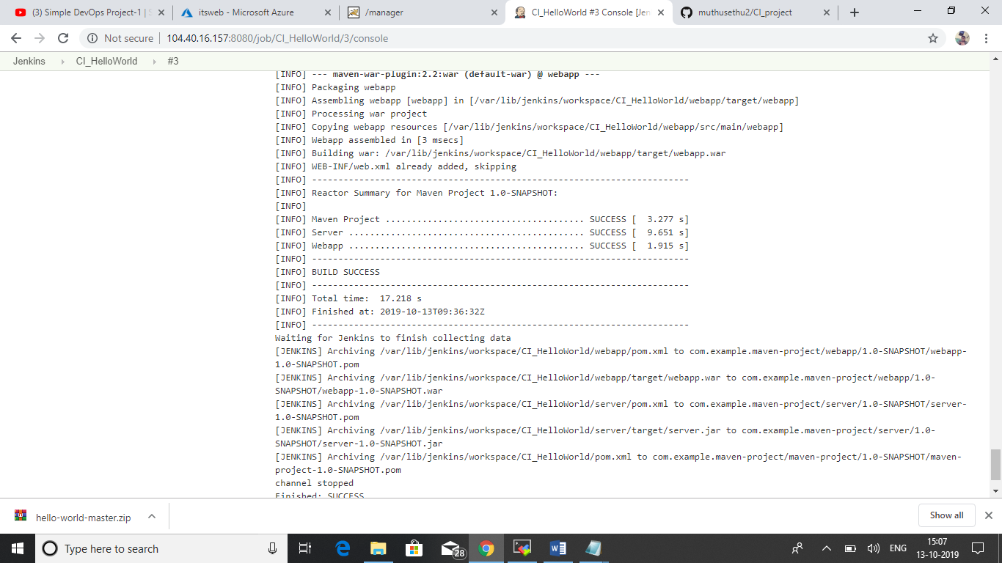

We need to publish the code after successful completion of build. So we need to setup the post build steps in the project. Initially we don’t have an option to publish the build in the server.

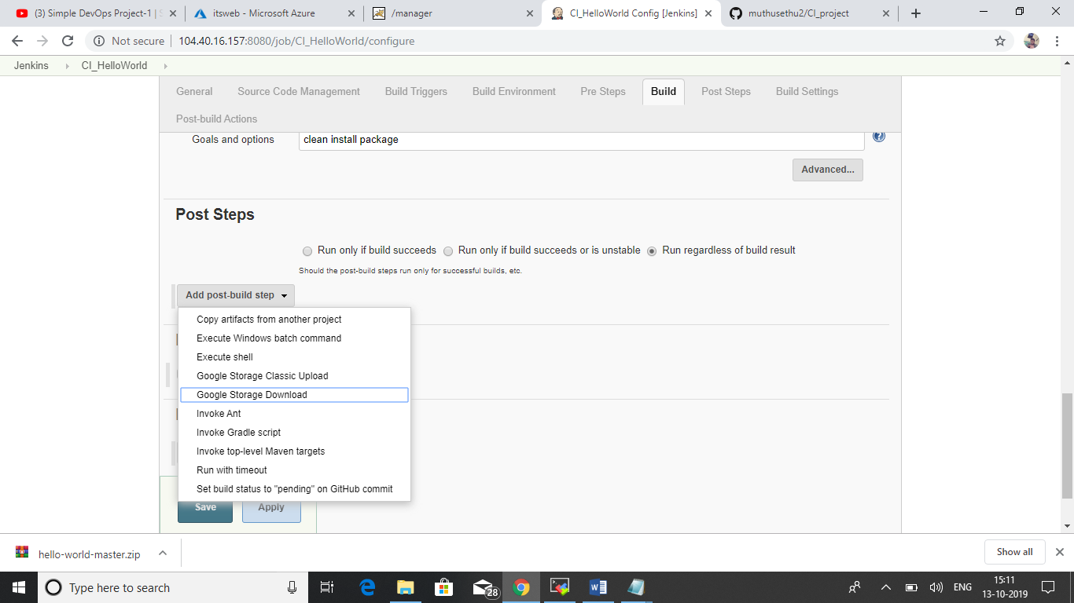

We need to enable Deploy to container plugin for publishing our successful build to server or container.

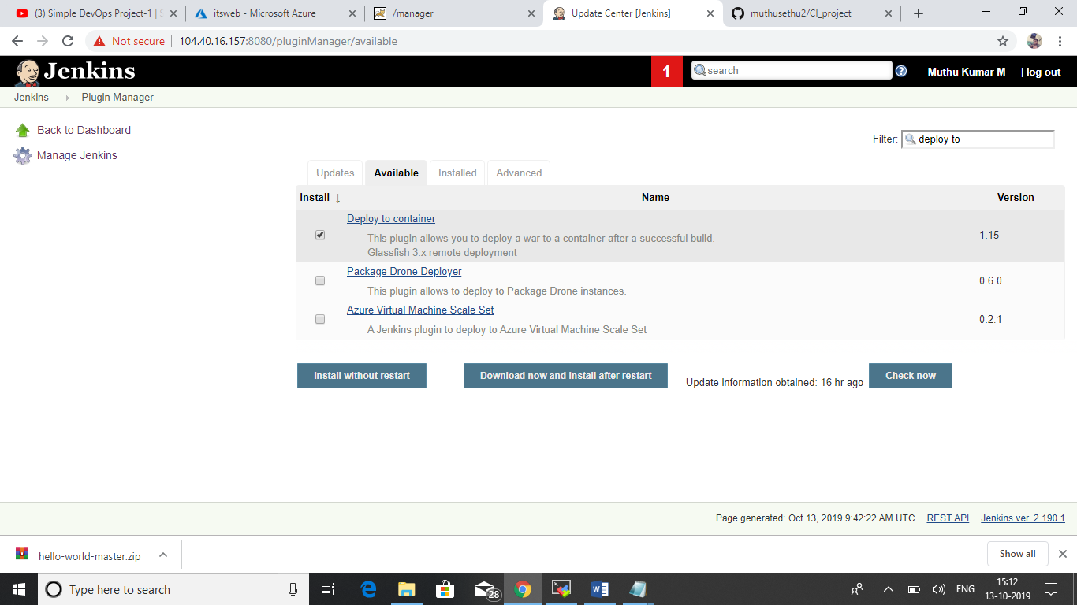

Now we can able to see the option war/ear to a container. Select the option in the post build and give the required details like URL and credentials of the web server (Tomcat).

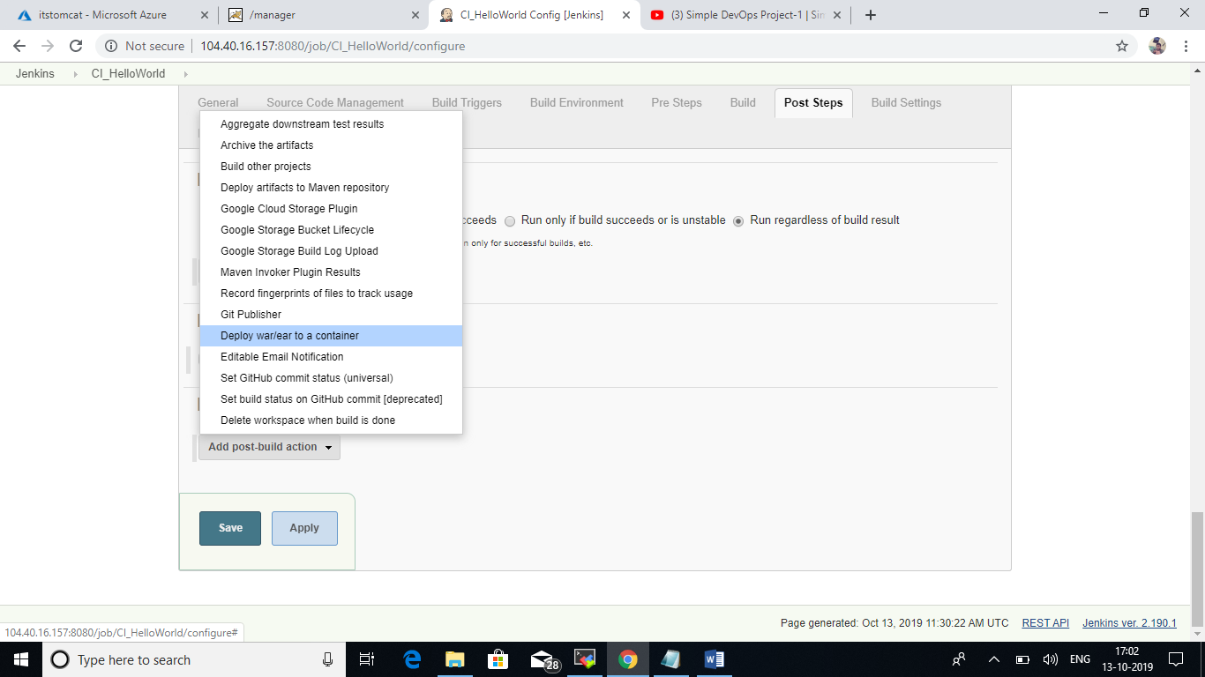

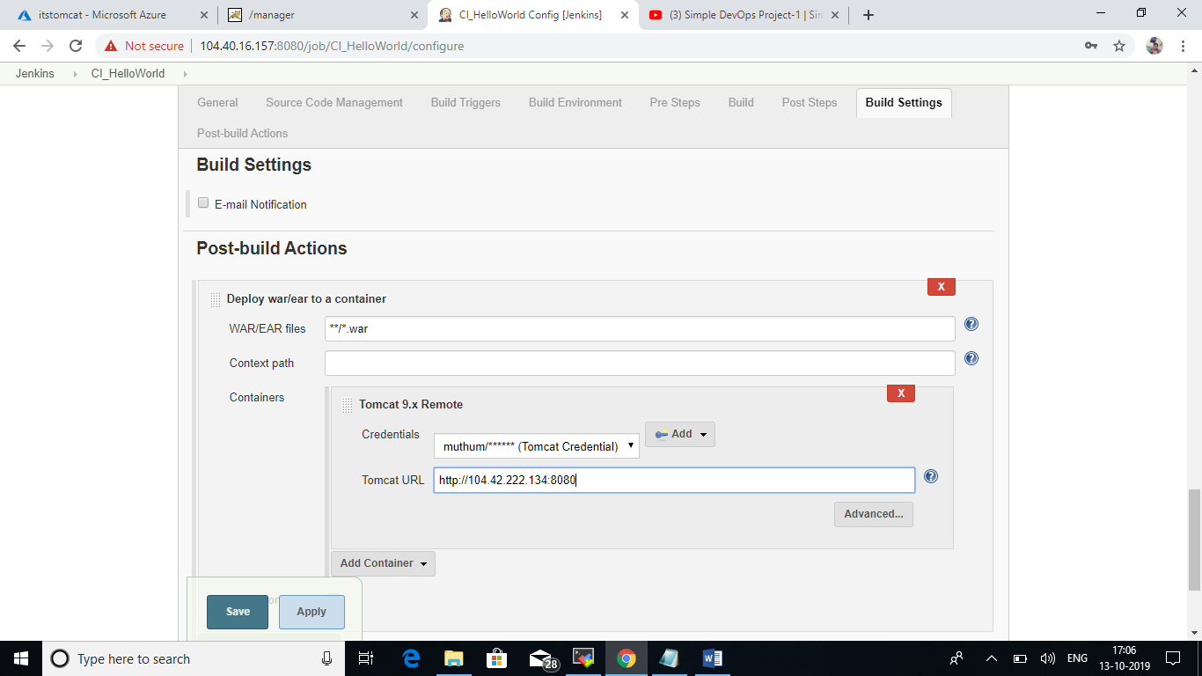

After successful configuration we can able to see the war file in the web server.

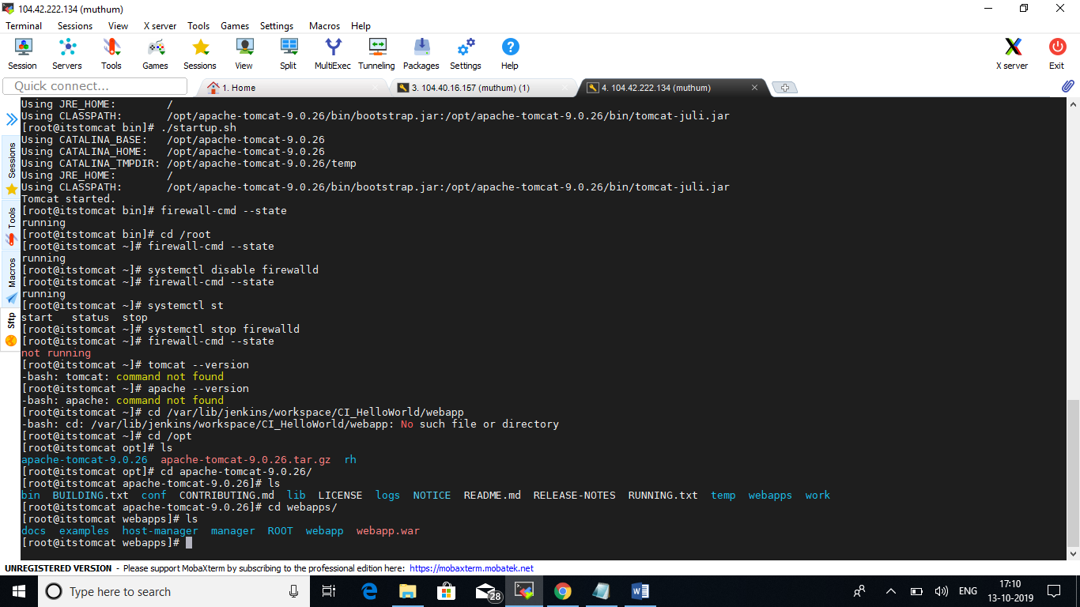

Our first build completed and published successfully!!

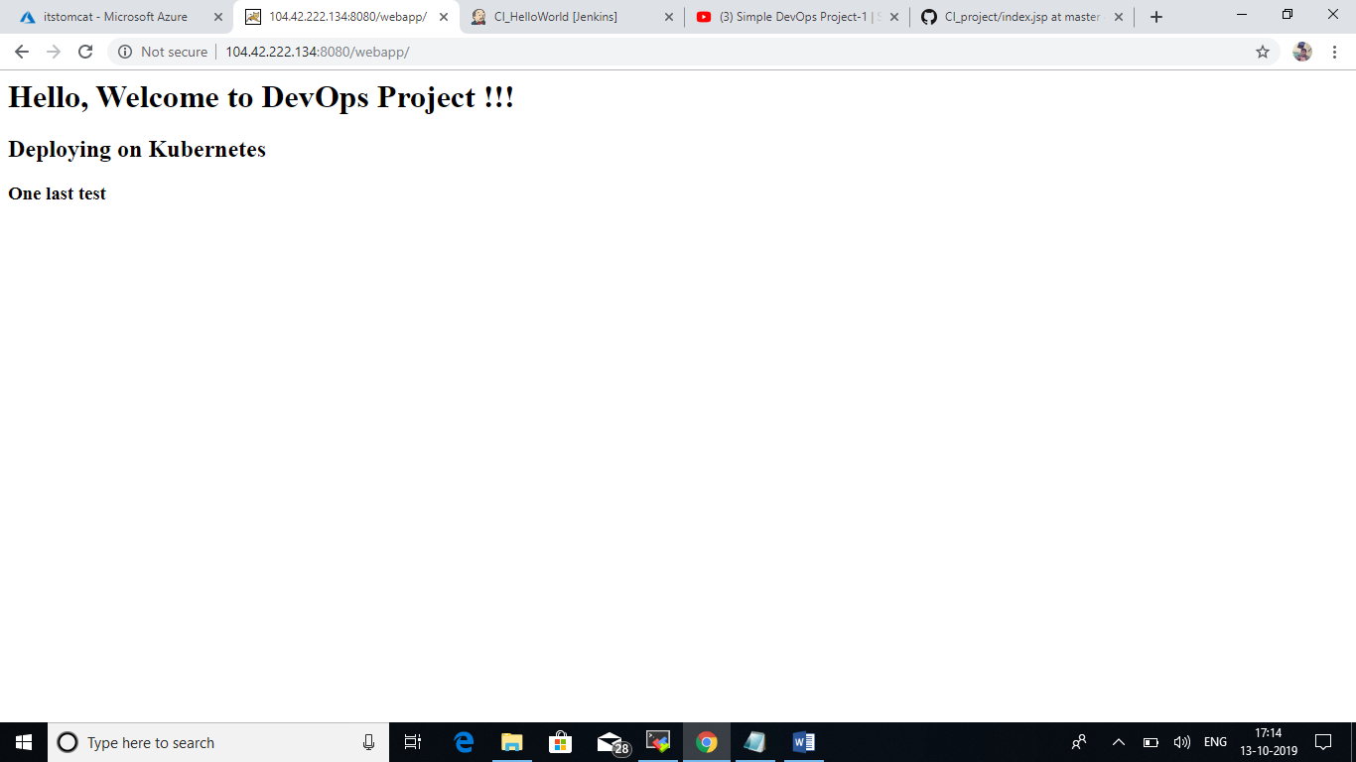

Now we are setup the automated build triggers for the project. Here I configured 2mins for the next build. It will trigger the build automatically whenever the changes happened in SCM.

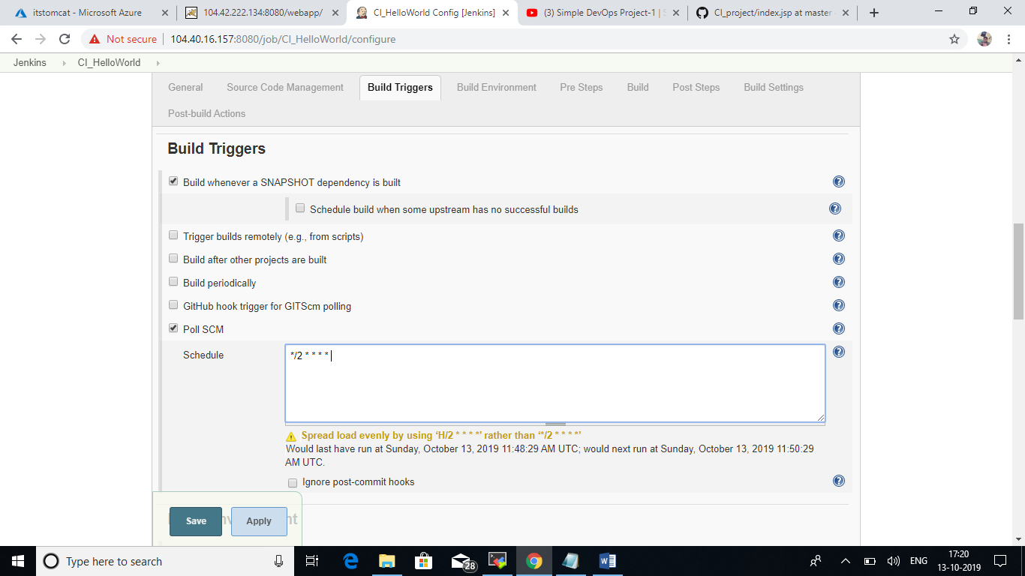

Next, I changed the source code in SCM. The build triggers automatically after 2Mins of the changes committed in the SCM.

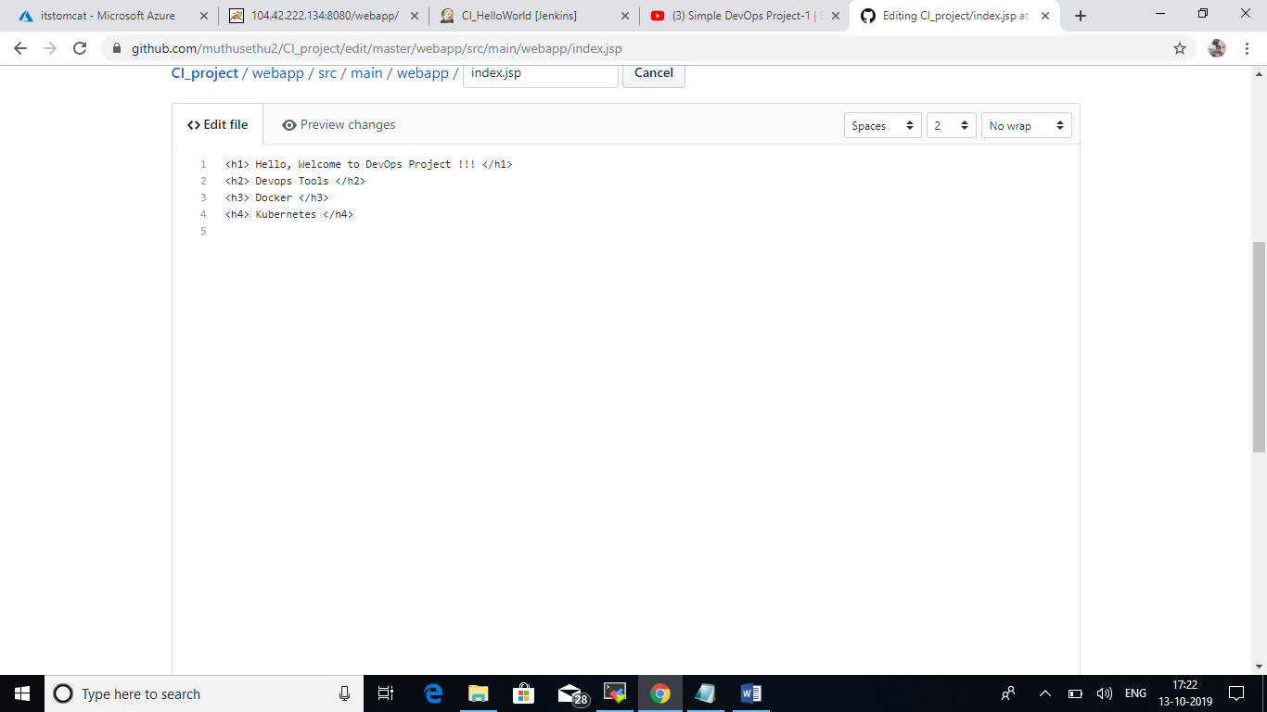

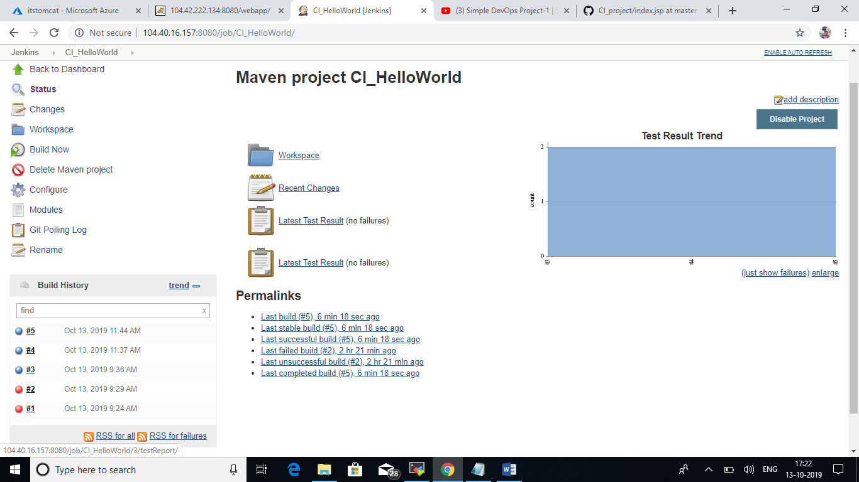

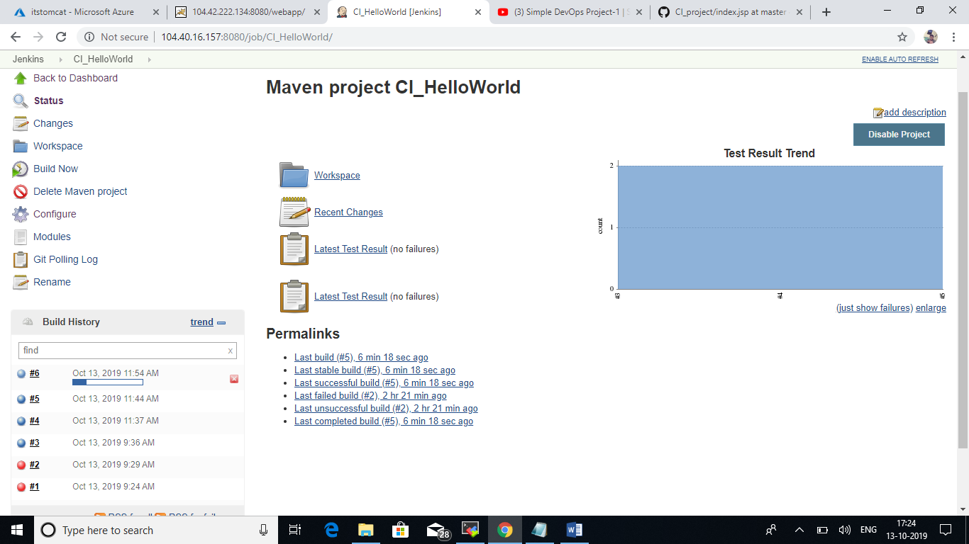

Next build is completed and published in the Server!!

